How to change your Moodle eVoLvE User Profile Picture

Once you have logged into your Moodle Evolve account. If you wish to change your Moodle Evolve User Profile Picture follow these instructions.

Select My Profile Settings then Edit Profile in the left hand column under Settings.

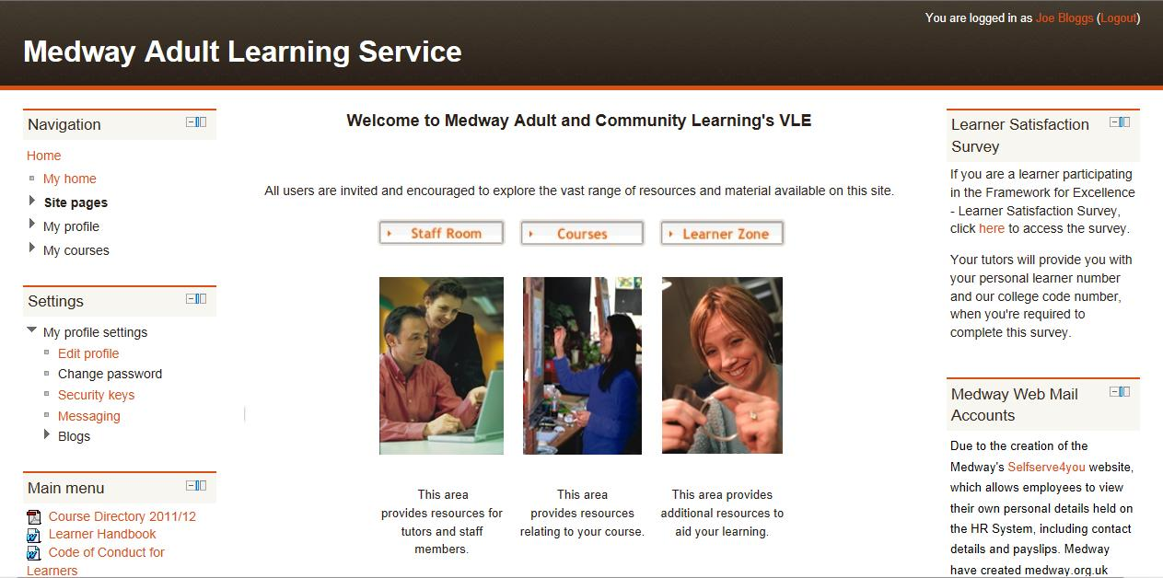

A new page called Edit Profile will appear, scroll down the page until you find the User picture section. To up a new user picture, select the Choose a File button

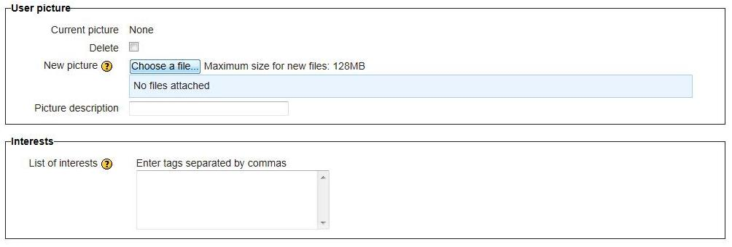

A new window will open called File Picker. Select Upload a File in the left hand column. Then select the Browse button.

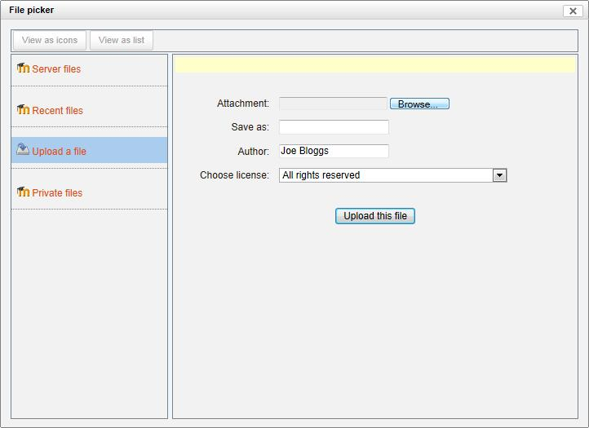

This will allow you to browse your computer folders for a photo to upload. Once you have located a photo, select that photo and click on the Open button.

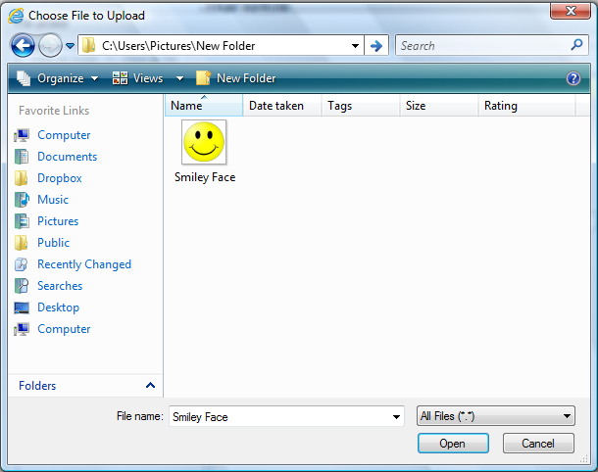

You will return to the File Picker page automatically and your photo filename will appear in the attachment box. Now select the Upload this File button.

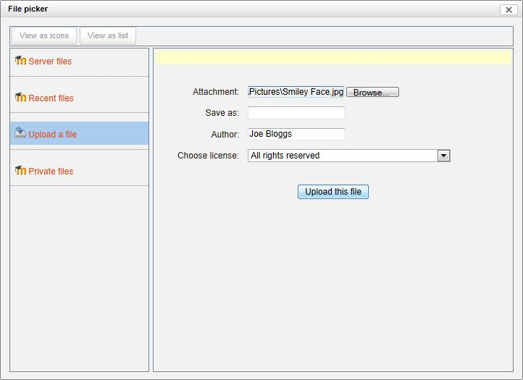

You will return to the Edit Profile page automatically and notice your photo filename will appear in the New Picture box.

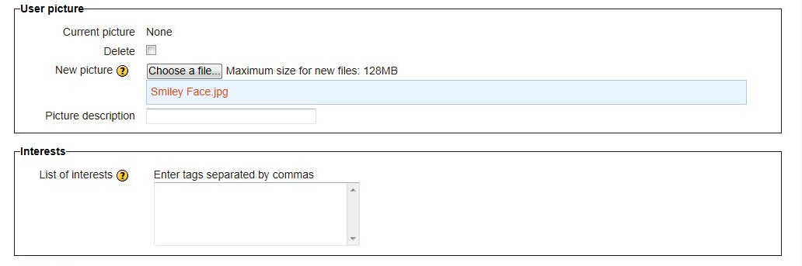

Now scroll down to the bottom of the page until you find the Update Profile button and select it. This will save your new settings and display your new profile picture.

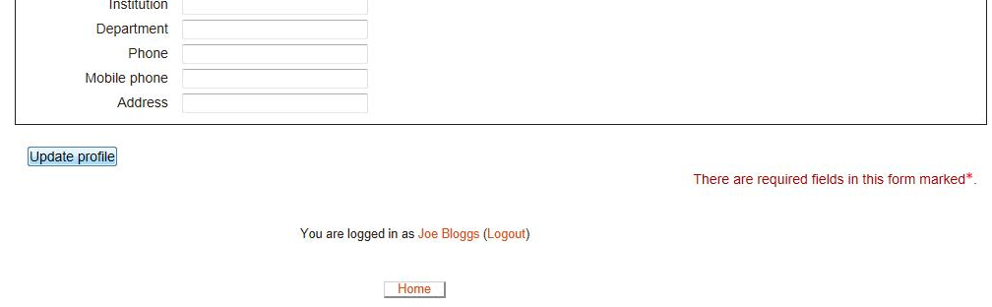

If you need any help, please contact our admin team on 01634 338424, enquiries@medway.gov.uk

