How to upload a file to Moodle eVoLvE

Once you have logged into your Moodle Evolve account. If you wish to upload a file in to your course area, follow these instructions.

Navigate to your course area, where you want the file uploaded and select the Turn editing on button.

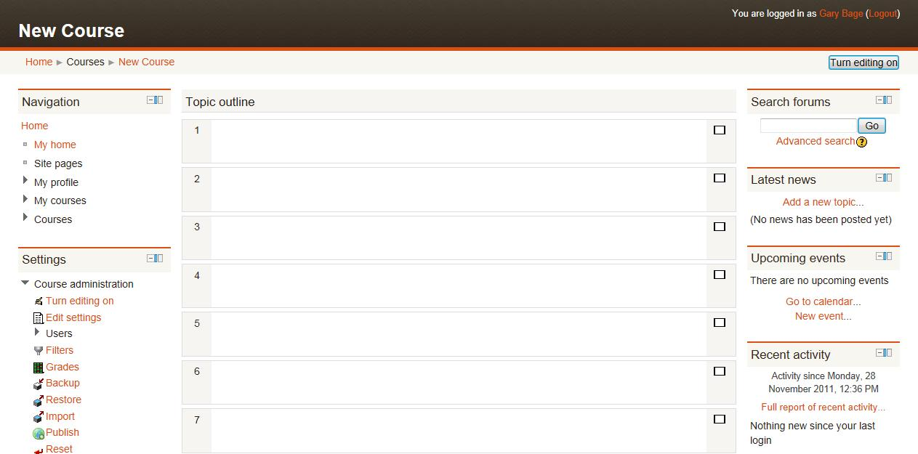

In the relevant topic section, click on Add a resource, then select file.

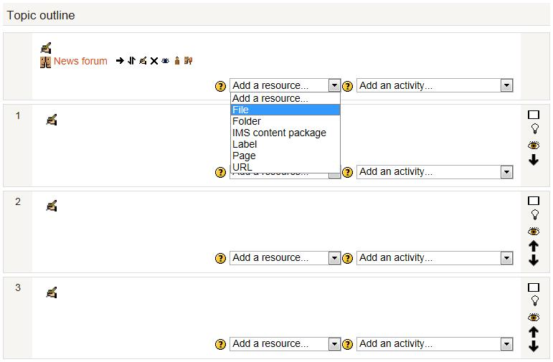

A new page will appear called Adding a new File. Enter a name and a brief description for the file into the relevant boxes to help explain the file to your learners.

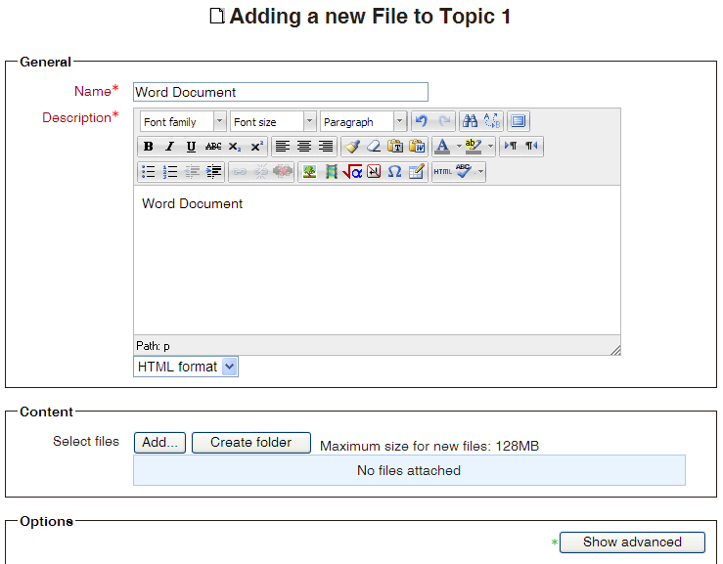

Then scroll down to the Content section and select the Add button.

A new window will open called File Picker. Select Upload a File in the left hand column. Then select the Browse button.

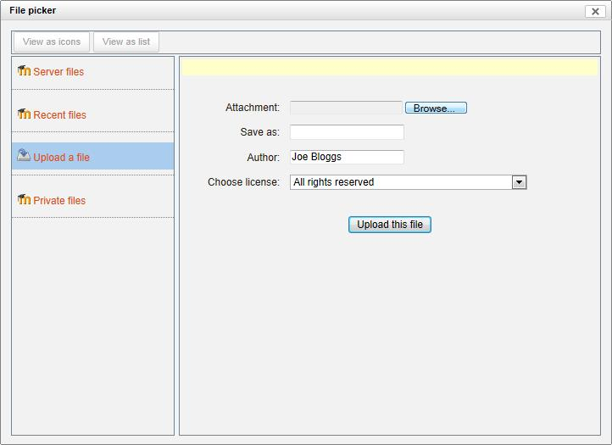

This will allow you to browse your computer folders for the file you want to upload. Once you have located the file, select the file and click on the Open button.

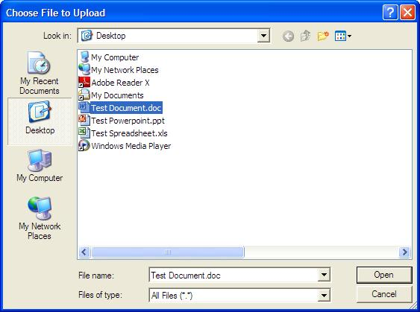

You will return to the File Picker page automatically and your file’s filename will appear in the attachment box. Now select the Upload this File button.

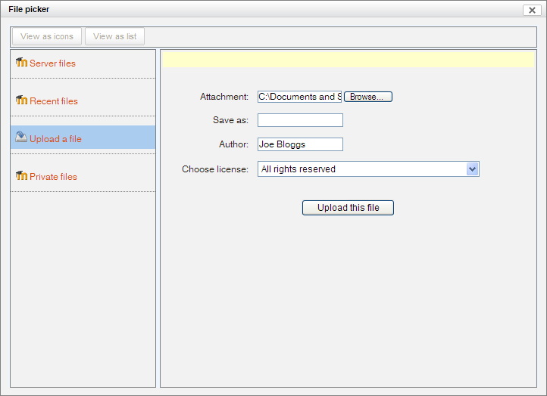

Now scroll down to the bottom of the page until you find the Save and return to course button and select it. This will save your file’s settings and display it in your course area.

