How to create a Web Link on Moodle eVoLvE

Once you have logged into your Moodle Evolve account. If you wish to create a web link in your course area, follow these instructions.

Navigate to your course area, where you want to create the web link and select the Turn editing on button.

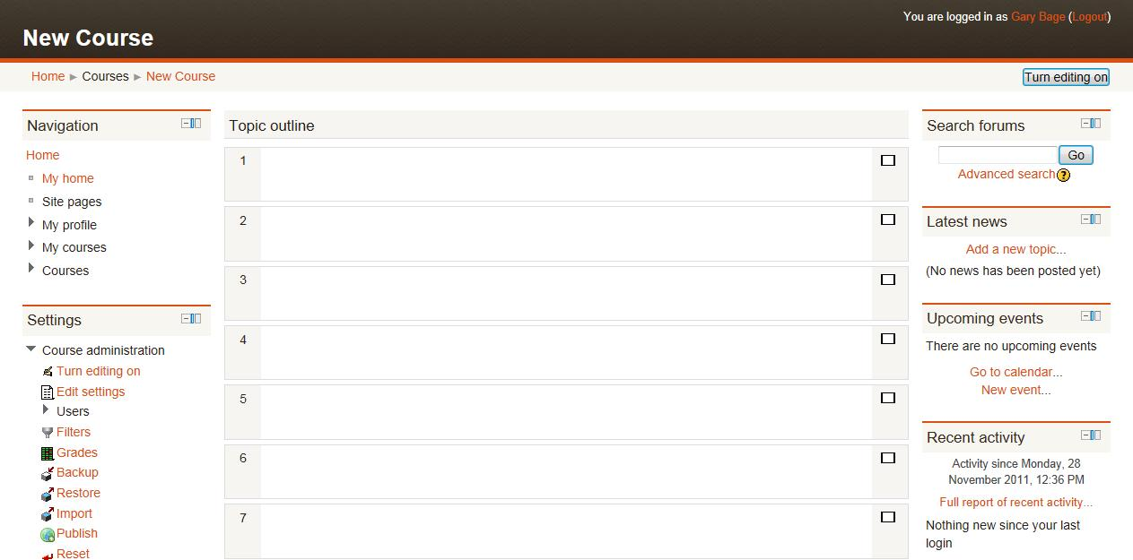

In the relevant topic section, click on Add a resource, then select URL.

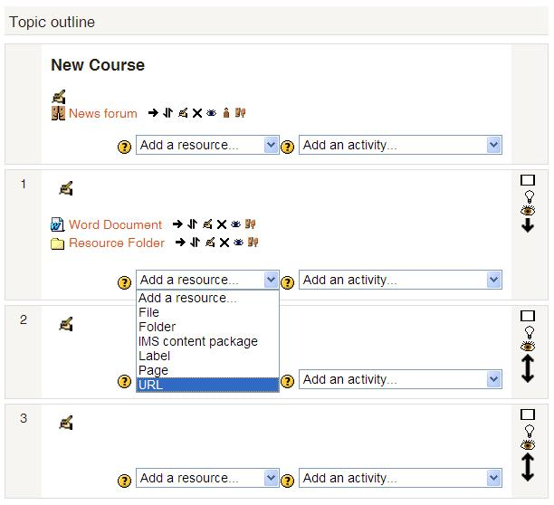

A new page will appear called Adding a new URL. Enter a name for the web link into the relevant box to help explain the link to your learners.

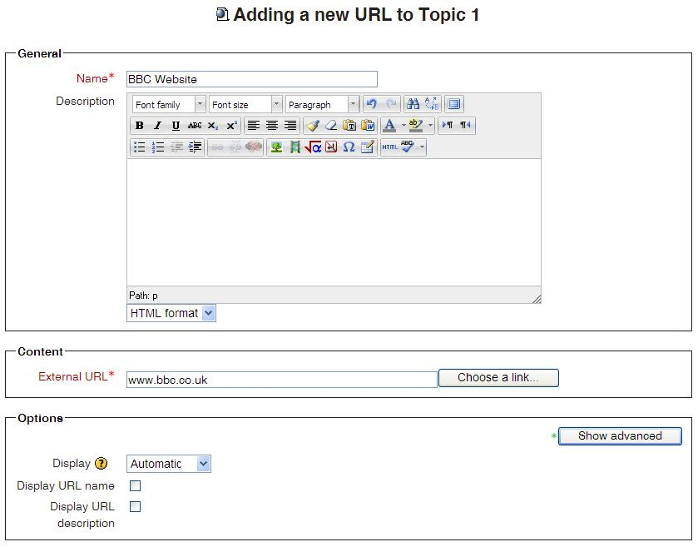

Then scroll down to the Content section and enter the relevant web address into the box called external URL.

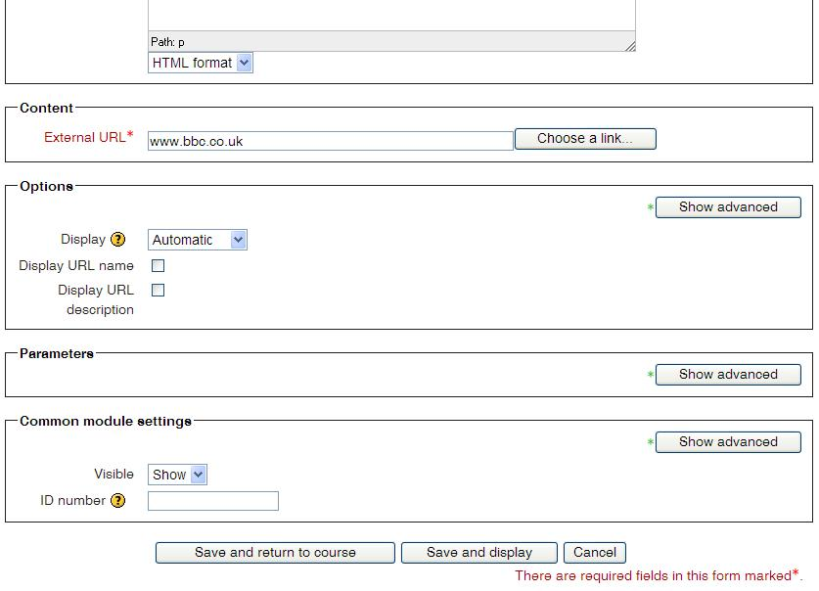

Now scroll down to the bottom of the page until you find the Save and return to course button and select it. This will save your web link’s settings and display it in your course area.

