How to create a Label on Moodle eVoLvE

A label is a way of breaking up a page and adding more information for the learner. Your course topics could end up as simply a list of files. The label allows you to insert explanatory text to inform the learner what to do with the file or pictures to make the page more interesting and colourful.

Once you have logged into your Moodle Evolve account. If you wish to add a label to your course area, follow these instructions.

Navigate to your course area, where you want to create the folder and select the Turn editing on button.

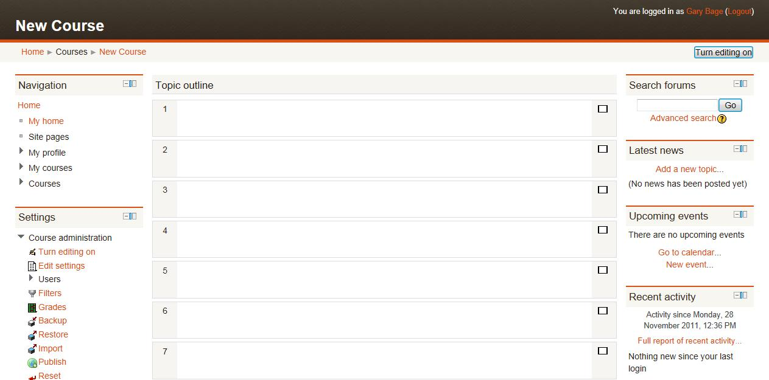

In the relevant topic section, click on Add a resource, then select Label.

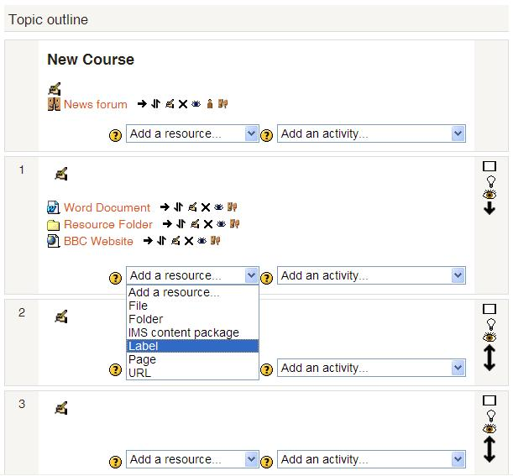

A new page will appear called Adding a new Label. You can put almost anything you want into a label, text, pictures or even embed videos and other multimedia files.

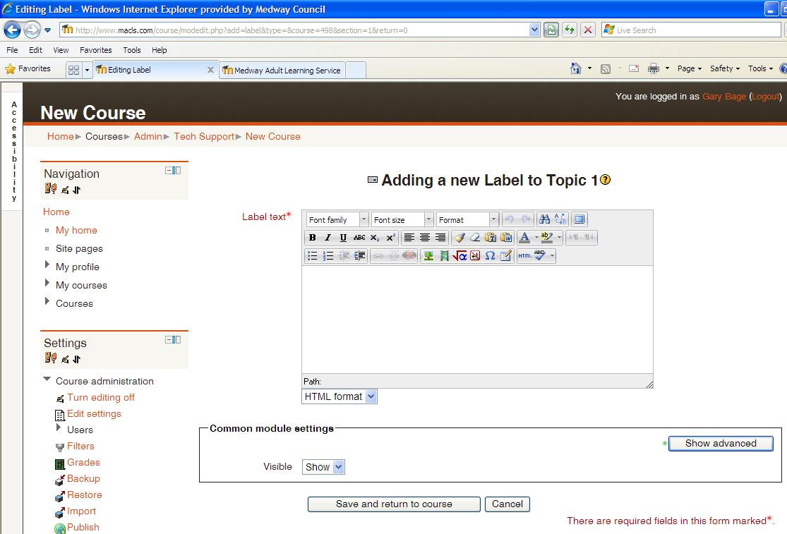

Once the label is finished, scroll down to the bottom of the page until you find the Save and return to course button and select it. This will save your label’s settings and display it in your course area.

