How to Change or Remove a User’s Permission Level within a Course Area

Once you have logged into your Moodle Evolve account. To change or remove a user’s permission level within a course area, follow these instructions.

Navigate to your course area, where you want to change the user’s role. Select Users then Enrolled Users in the left hand column under Settings.

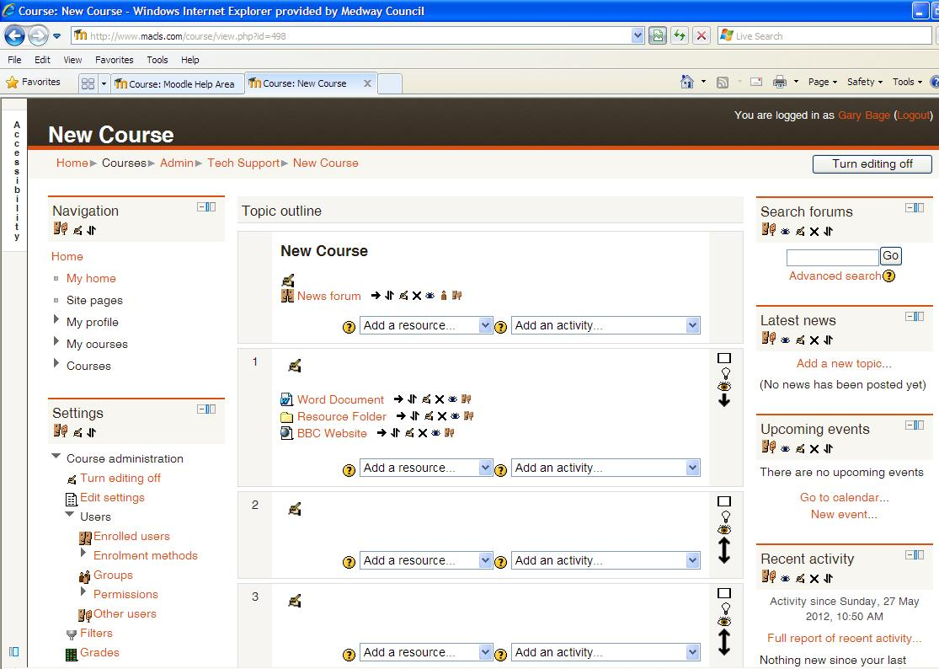

A new page will appear called Enrolled Users. If you wish to upgrade the user’s level of permission and give them editing rights. Select the Plus symbol within the Roles column next to the user’s name, which you wish to edit. Then select Teacher, this will allow the user to be able to upload, edit or delete any content within this course area.

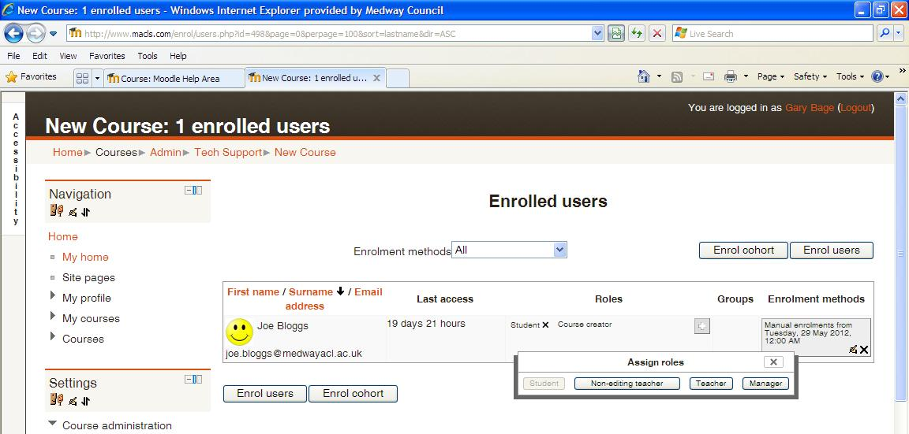

If you are looking to downgrade a user’s level of permission and remove their editing rights. Select the Cross symbol next the role you wish to remove from the user, in this case, next to the Teacher role. The user will still have student permission within this course area, therefore will still be able to visit the course area. However they will no longer be able to upload, edit or delete any content within this course area.

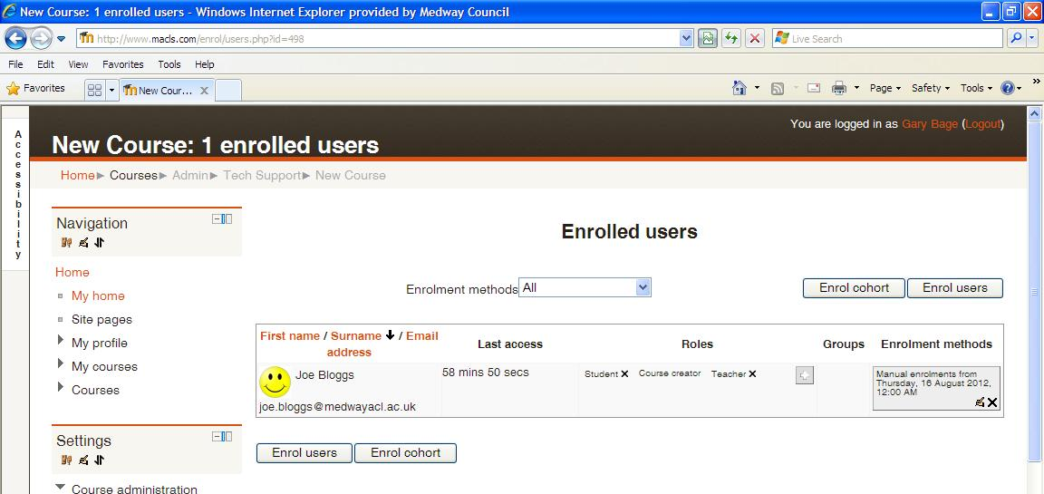

To remove a user completely from a course area, select the Cross symbol within the Enrolment Methods column next to the user’s name. A confirmation screen will appear to double check your choice, select Continue and this will remove them from the course area and deny them any future access to this course area.

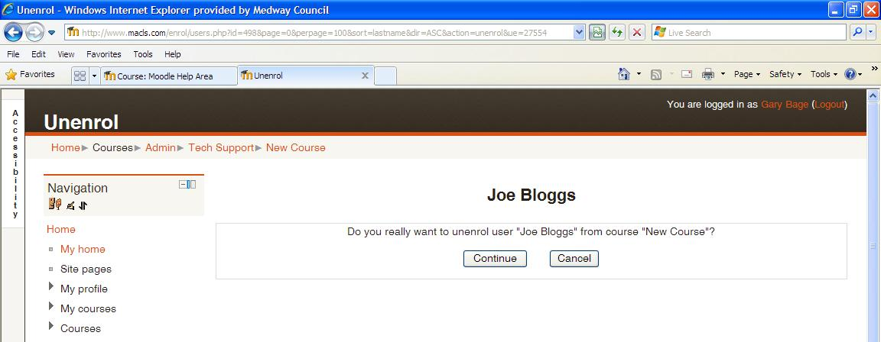

If you need any help, please contact our admin team on 01634 338424, enquiries@medway.gov.uk

