How to post messages on to a forum in Moodle eVoLvE

Once you have logged into your Moodle Evolve account. If you wish to post a message to your learners through a forum, follow these instructions. Messages posted in the forum will be both displayed within the course area and emailed out to every member within the course area.

Navigate to your course area, where you want to post a message via the forum to your learners and select the forum you wish to use. Every course area comes with a standard News Forum by default. This allows users with teacher permission to post messages to every member enrolled within the course area. However this forum only allows one-way communication where no one can reply to posted messages. However more interactive forums can be created, which allow for two-way communication (see How to create an Interactive Forum).

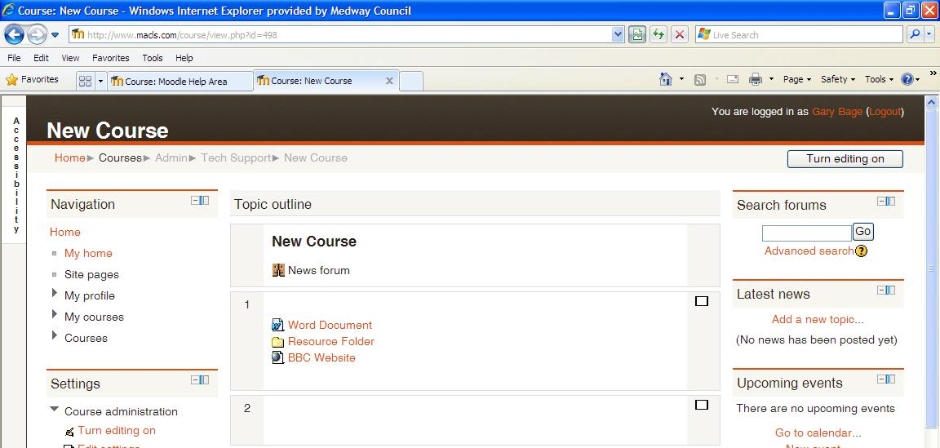

Once the forum opens, select ‘Add a new topic’.

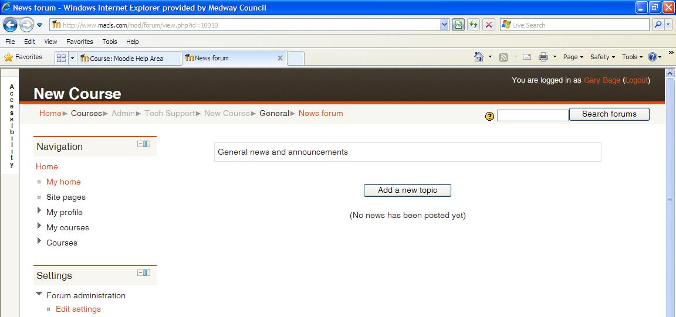

A new window called Your new discussion topic will open, where you write your post, very similar to a normal email, asking for a subject title and then an area for the general blurb. This post will be emailed out to all your learners with Moodle accounts within your course area.

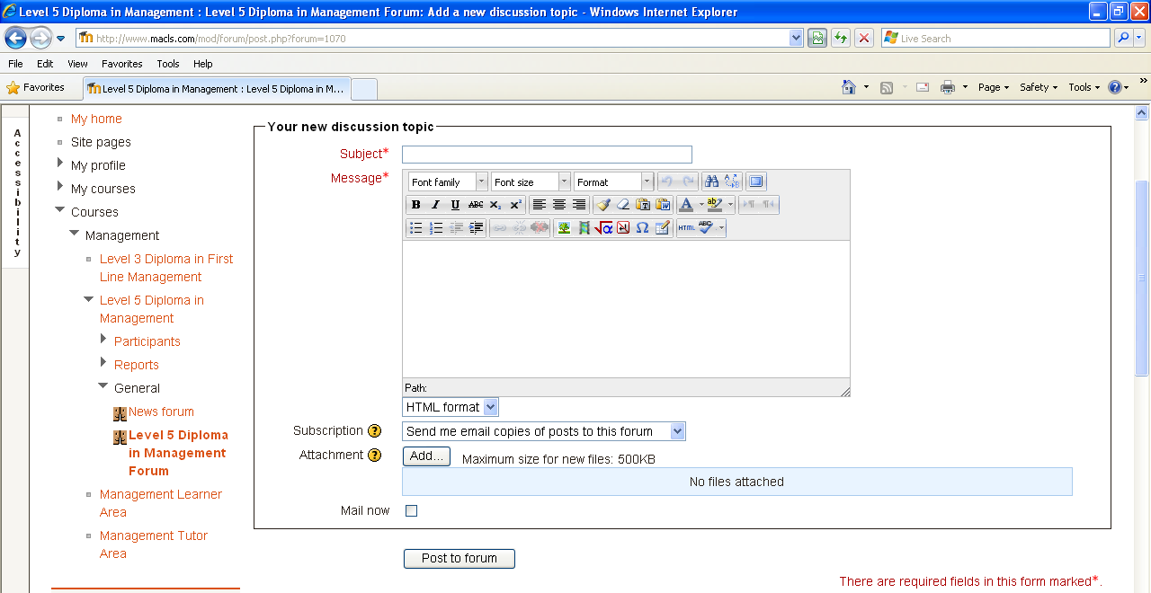

You also have the option to add attachments to your posts, so to be able to send documents with your post, as well. Once you’ve finished, selected the ‘Post to forum’ button to post your message to the forum and emailed out the message to your learners on your course with Moodle accounts.

