How to create an Interactive Forum

Every course area comes with a standard News Forum by default. This allows users with teacher permission (editing rights) to post messages to every member enrolled within the course area. The messages are posted in the forum on the website and also emailed out to every member.

This can be very useful for tutors wishing to contact all their learners to remind them that next week is half term and there will not be a lesson or to remind learners they need to bring a certain piece of equipment with them to their next lesson, etc. Only users with teacher permission (editing rights) can post messages to the news forum and no one can respond to them. They can only be viewed by others.

If you wish to create a more interactive forum, where all members (both student and teacher permissions) of the course area can post messages and reply to them, follow these instructions below.

Once you have logged into your Moodle Evolve account. Navigate to your course area, where you want to create the Interactive Forum and select the Turn editing on button.

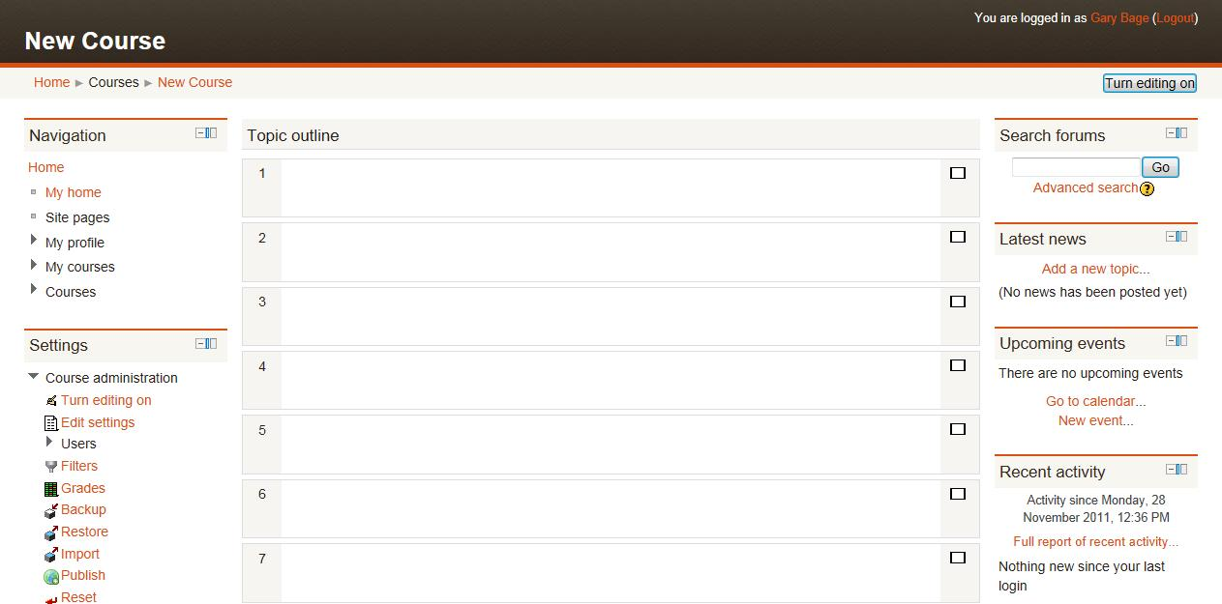

In the relevant topic section, click on Add an activity, then select Forum.

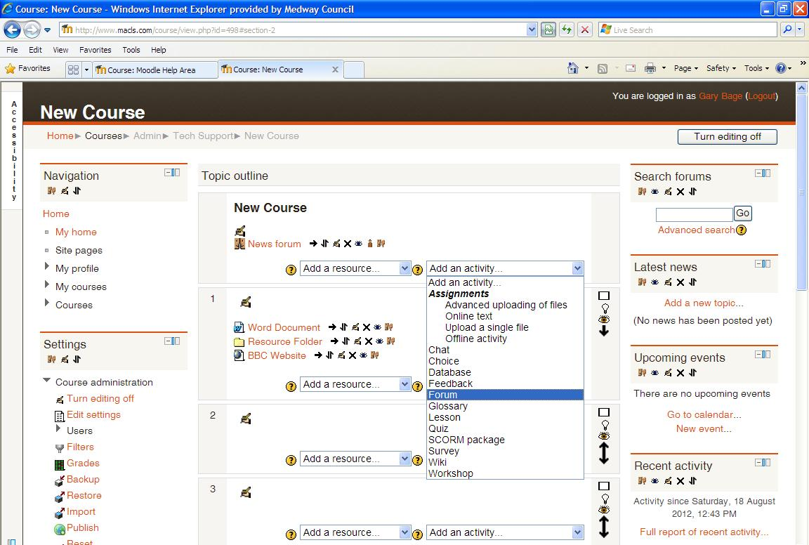

A new page will appear called Adding a new Forum. Enter a name and a brief description about the forum into the relevant boxes to help explain the forum to your learners.

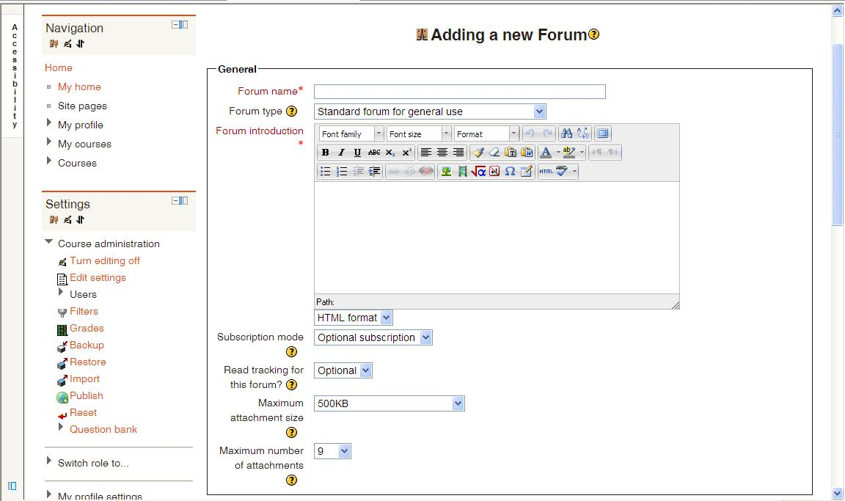

Check the Forum type is set as Standard forum for general use. This will allow for a more interactive forum than the news forum already available by default.

You have the option of selecting a Subscription Mode. When a user is subscribed to a forum it means they will receive email copies of forum posts. There are 4 subscription mode options:
- Optional subscription - Participants can choose whether to be subscribed or not
- Forced subscription - Everyone is subscribed and cannot unsubscribe
- Auto subscription - Everyone is initially subscribed but can choose to unsubscribe at any time
- Subscription disabled - Subscriptions are not allowed

It’s your choice which subscription mode you choose to use, but I may advise using either Forced subscription so all members of the course area can always receive your forum messages or using Auto subscription so members start off receiving all your forum messages but can choose to unsubscribe if they wish.

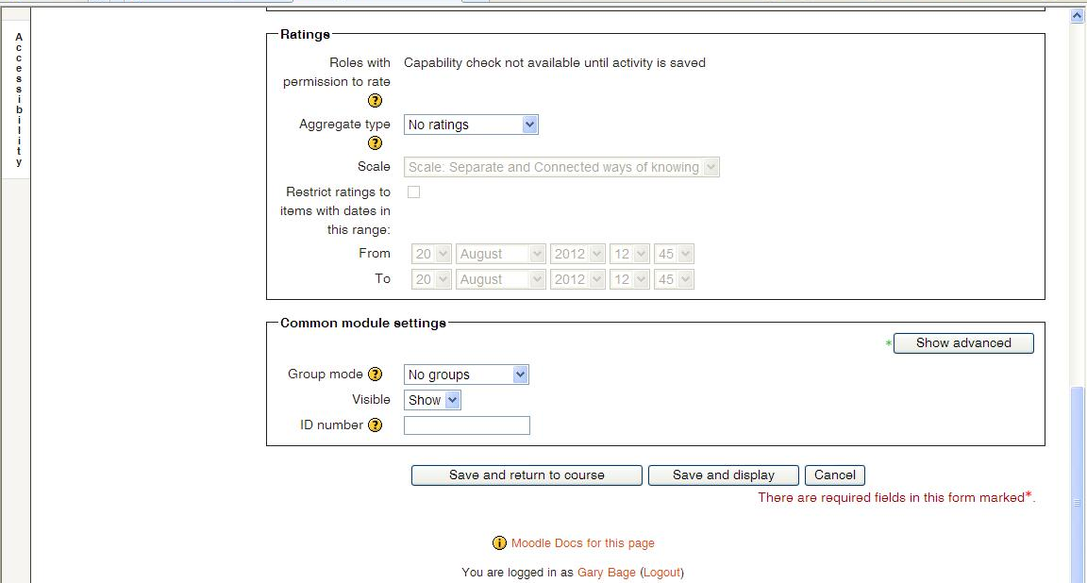

Once you have set which subscription mode you wish to use, scroll down to the bottom of the page until you find the Save and return to course button and select it. This will save your forum’s settings and display it in your course area.

