What the Editing Icons mean in your Course Area
To make any changes in a course area, first select the ‘Turn editing on’ button in the top right-hand corner of the page.
Then once your page has refreshed, you should see all the editing icons appear too. Here is a guide on what those icons mean and do.

Move Right - allows you to indent items to the right. A move left icon will appear after using the move right icon, which allows you to move items back left again.
Move - allows you to move items within a list inside the same topic box or to a completely different topic box.
Show / Hide - allows you to hide items from learners.
Open eye – show – means visible to students
Closed eye – hidden – means greyed out to staff, but invisible to students.
Assign Roles - allows you to locally assign permission roles to an item.
Not normally used, so wouldn’t worry about.

Edit Summary - allows you to create a topic box title.

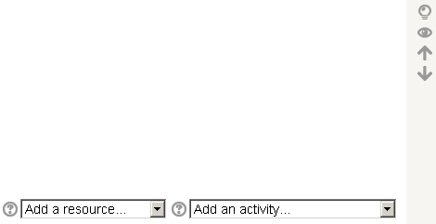
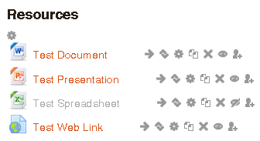
Hovering over any of the icons with your cursor will give you a brief explanation of that icon.
Selecting the Question Mark next to an item will open a brief help message relating to that item.
Edit / Update - allows you to edit or update items created or uploaded.
Delete - allows you to permanently delete items from the course area.
Add a Resource - opens a drop-down menu offering resource type that you can insert or create.
Add an Activity - opens a drop-down menu offering the different possible Moodle activities that can be created.
Duplicate - allows you to duplicate an item in your course area.
Highlight Current Topic - allows you to highlight a topic box
Show / Hide Topic - allows you to hide the topic box and all its content from learners.
Open eye – show – means visible to students
Closed eye – hidden – means greyed out to staff, but invisible to students.

Move Up / Down - allows you to move a topic box and all its content up and down the course page.
You can only move up or down one place at a time.

