**Text editor – Icons Guide**

Whenever you have to enter content into Moodle, you’ll find the **Text Editor** window, for example when you are editing a section heading, using a label to give an activity or resource a description, writing quiz questions and answers, etc. There are many icons available to help you edit and format the information you’re entering into the text editor. You will find that many of these icons and functions are very similar to those found in Microsoft Word.

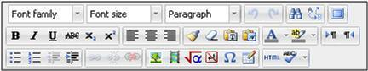

**Resizing the text editor**

To **resize** the text editor, click on and drag the bottom right-hand corner of the text editor box.

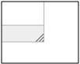

You can also see the text editor as a full screen by clicking on the **Toggle Full screen** **mode** button.

http://glyndwrmoodle.files.wordpress.com/2012/03/toggle-full-screen.jpg?w=500

**Buttons on the text editor**

The table below explains what the icons and functions available on the three rows of the text editor are:

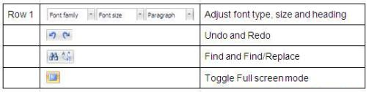

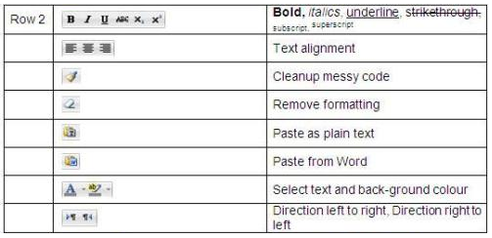

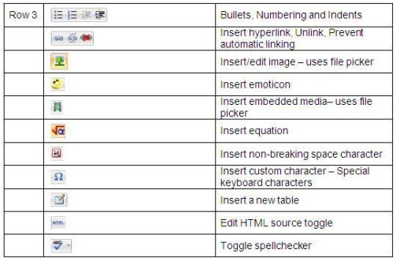

There are some great **video tutorials** produced by HRDNZ Moodle Partner as part of their MoodleBites series on YouTube, which explain how the icons and options on the different rows of the editor work:

[HRDNZ Moodle Partner Moodle Bites Moodle 2.0 HTML Editor – Row 1](http://www.youtube.com/watch?v=bBZQYGcDaMg&feature=plcp&context=C438664aVDvjVQa1PpcFNVMgQRq2C5r2Ejm-KXBw8SRFJEPwdbjHs=)

[HRDNZ Moodle Partner Moodle Bites Moodle 2.0 HTML Editor – Row 2](http://www.youtube.com/watch?v=uS_M6-eHsxE&feature=plcp&context=C47e52a5VDvjVQa1PpcFNVMgQRq2C5ryCQe9rmyC-bKYE6koahPZA=)

[HRDNZ Moodle Partner Moodle Bites Moodle 2.0 HTML Editor – Row 3](http://www.youtube.com/watch?v=3rRztnWkhuY&feature=plcp&context=C4f7fec4VDvjVQa1PpcFNVMgQRq2C5r2GiV3cE2EnIDZLtjVLF5CQ=)

**Using the spellchecker**

To use the spellchecker, click on the **Toggle spellchecker** button. Any words spelt incorrectly will be underlined in red. Click on the underlined word to see a list of possible suggestions. You can choose one of these suggestions or you can choose to ignore them.

