How to create a Folder on to Moodle eVoLvE

Once you have logged into your Moodle Evolve account. If you wish to create a folder for resources in your course area, follow these instructions.

Navigate to your course area, where you want to create the folder and select the Turn editing on button.

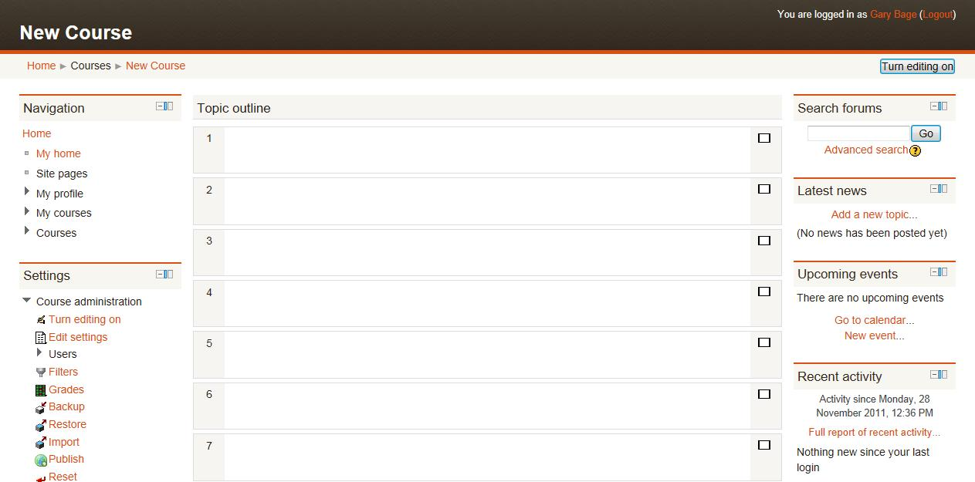

In the relevant topic section, click on Add a resource, then select Folder.

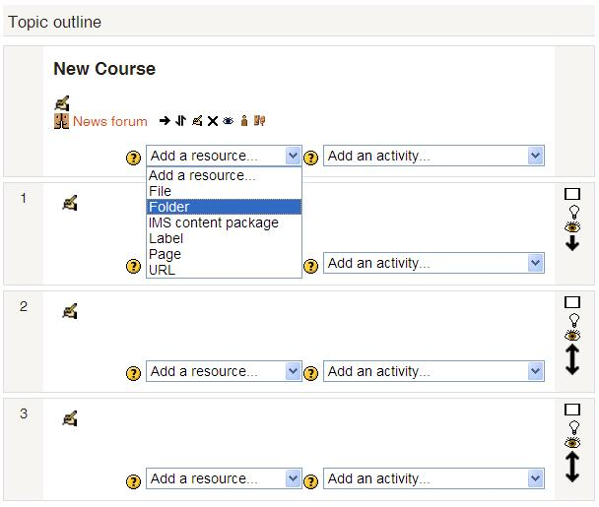

A new page will appear called Adding a new Folder. Enter a name and a brief description for the folder into the relevant boxes to help explain the folder’s purpose to your learners.

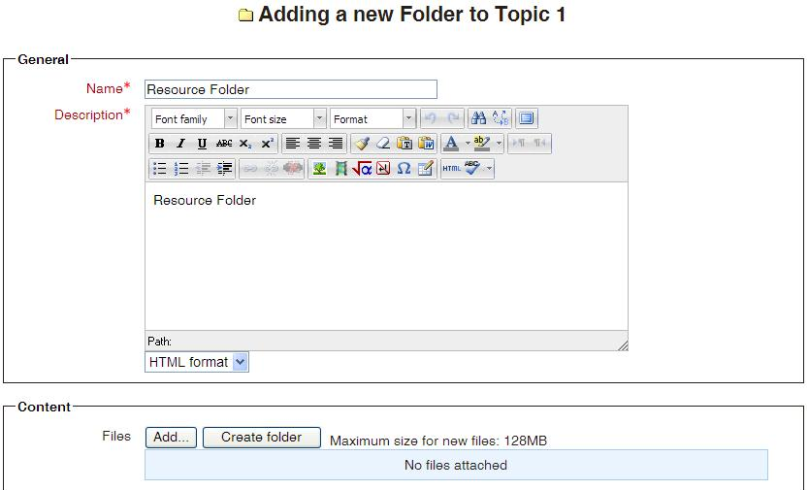

Then scroll down to the Content section and select the Add button.

A new window will open called File Picker. Select Upload a File in the left hand column. Then select the Browse button.

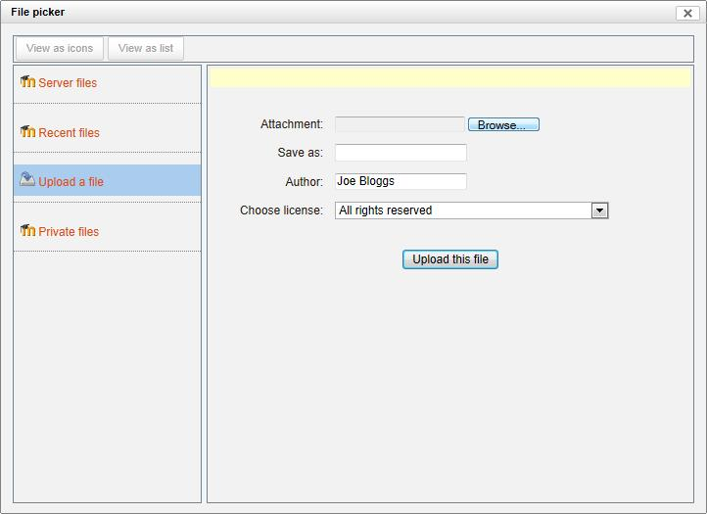

This will allow you to browse your computer folders for the file you want to upload. Once you have located the file, select the file and click on the Open button.

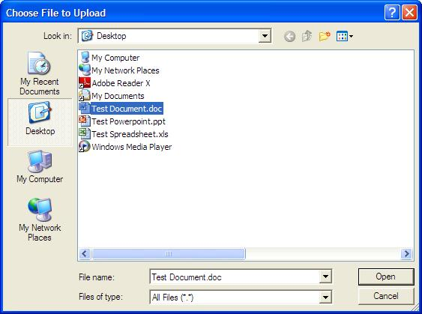

You will return to the File Picker page automatically and your file’s filename will appear in the attachment box. Now select the Upload this File button.

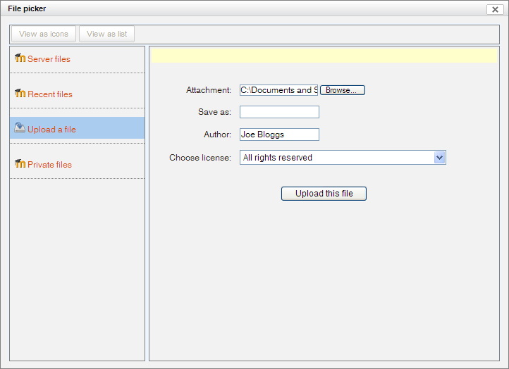

You will return back to the Adding a new Folder page. You have either the choice to repeat the process above and add more files into this folder or scroll down to the bottom of the page until you find the Save and return to course button and select it. This will save your folder’s settings and display it in your course area.

