How to change your Moodle eVoLvE Password

Once you have logged into your Moodle Evolve account. If you wish to change your Moodle Evolve password follow these instructions.

Select My Profile Settings then Change Password in the left hand column under Settings.

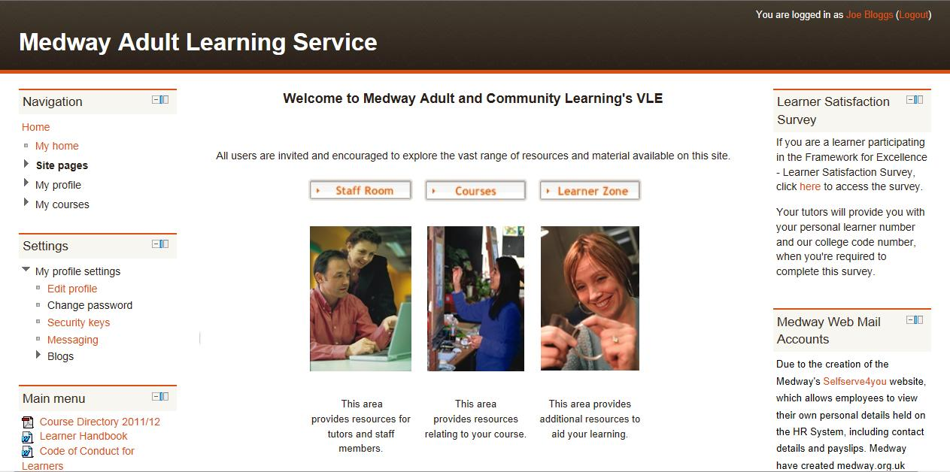

Then type your current password followed by your new password twice here.

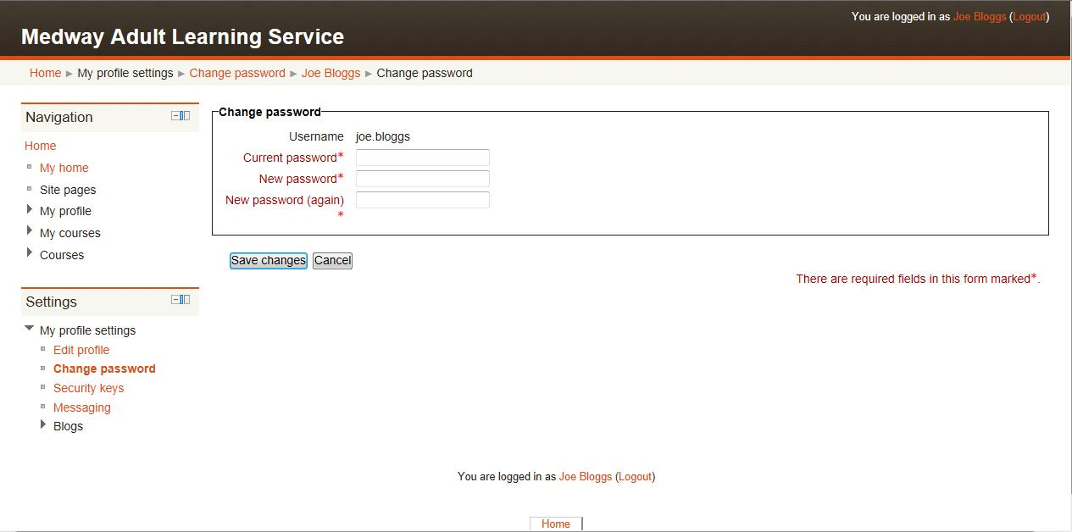

Once you’re finished entering your new password, select the Save Changes button.

If you are not sure about your user name or password, please contact our admin team on 01634 338424 or enquiries@medway.gov.uk They can check your user name and change your password if necessary.

