How to log into Moodle eVoLvE

Type www.macls.com into the address of your internet browser:
Click in the address bar and delete what is there first.
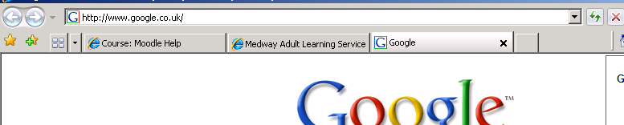

The Moodle eVoLvE home page appears and you will need to put your user name and password into the boxes at the top left-hand side. The user name is usually in the format:

firstname.surname

Your password is set up as password originally but it is recommended that this is changed when you log in.
Type in your user name and password here
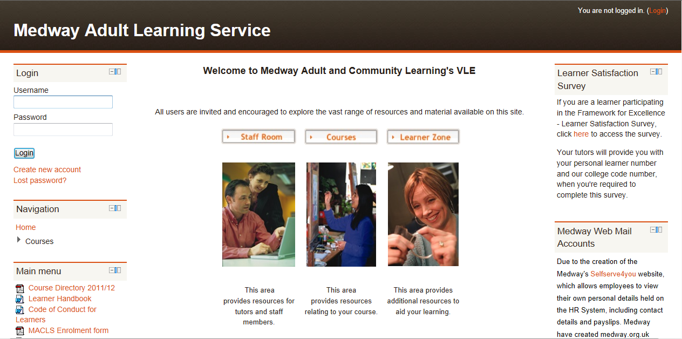

If you are not sure about your user name or password, please contact our admin team on 01634 338424, or enquiries@medway.gov.uk They can check your user name and change your password if necessary.

