How to hide your Email Address on Moodle eVoLvE

Once you have logged into your Moodle Evolve account. If you wish to hide your email address on Moodle Evolve follow these instructions.

Select My Profile Settings then Edit Profile in the left hand column under Settings.

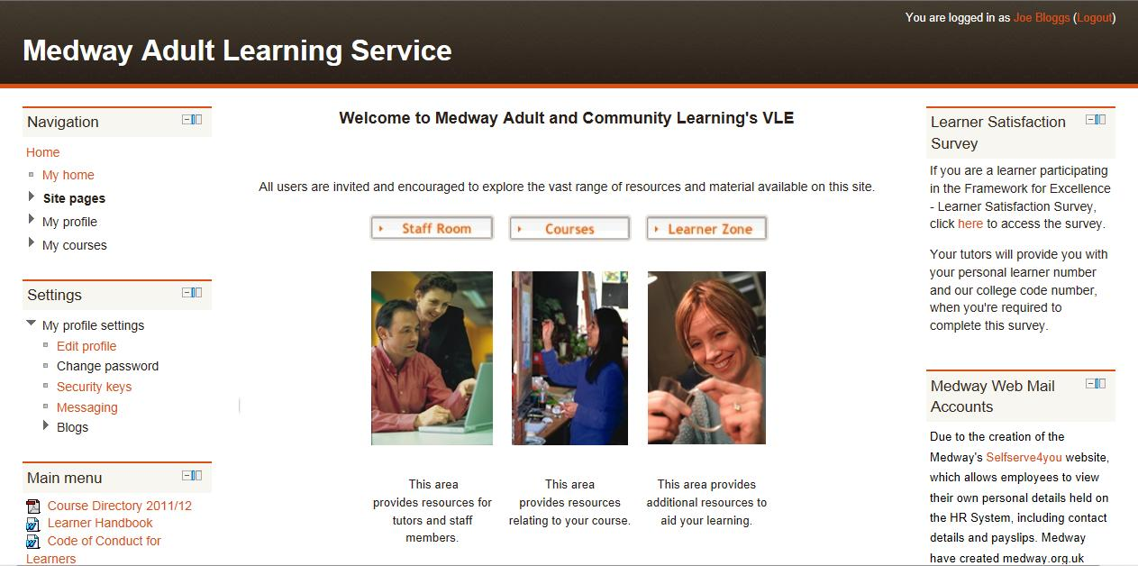

A new page will open called Edit Profile. This page displays and allows you change any of your user details, email address and even allows you to upload a profile picture, if you wish.

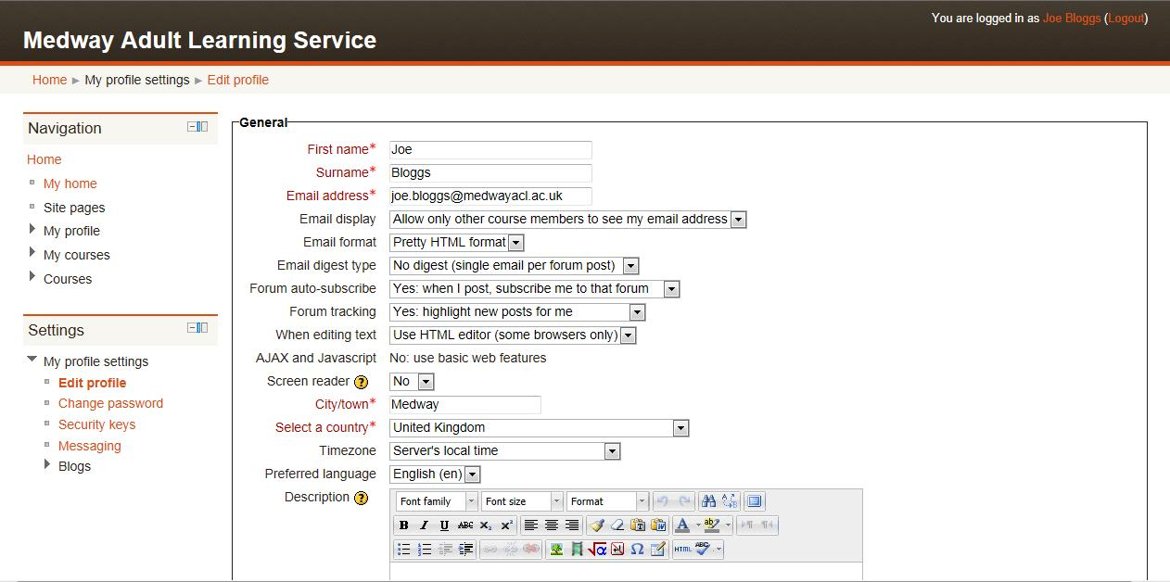

To hide your email address, select the arrow next to Email Display to open the drop-down menu.

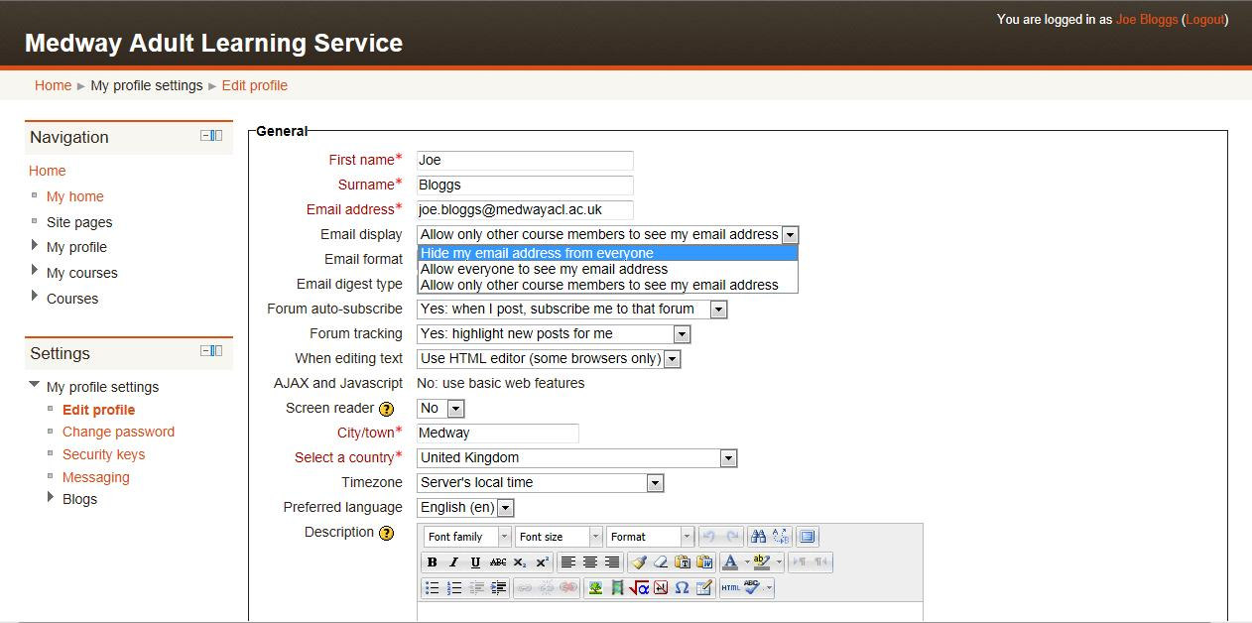

The drop-down menu will give you three options to choose from:

- Hide my email address from everyone
- Allow everyone to see my email address
- Allow only other course members to see my email address

Choose which option you feel most comfortable with. Once you have made your decision, scroll to the bottom of the page and select the Update Profile button.

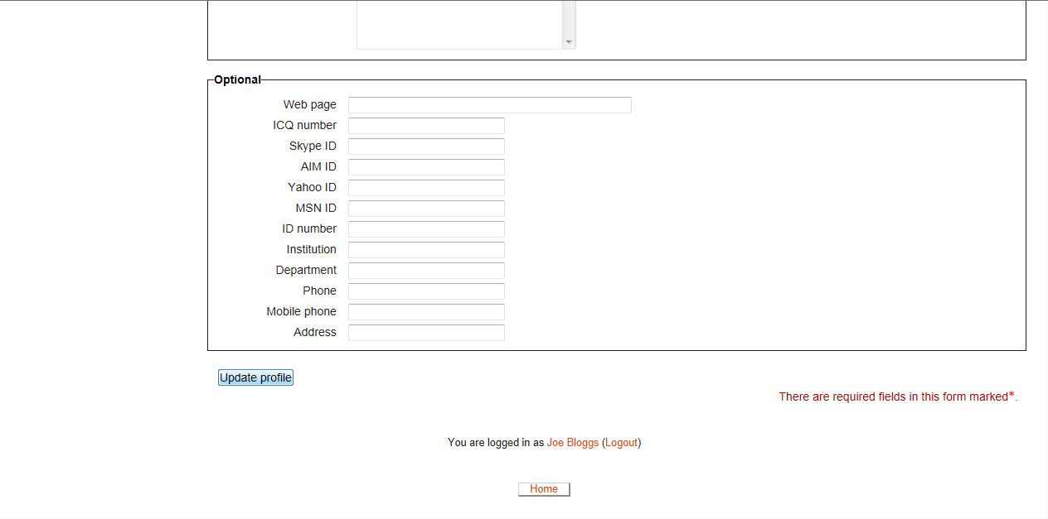

If you need any help, please contact our admin team on 01634 338424, enquiries@medway.gov.uk

