Moodle eVoLvE FAQs

I can’t remember my user name and/or password.

Contact Gary or Jamie. They can check up on your user name and reset your password if necessary.

garybage@medway.gov.uk 338484
jamie.may@medway.gov.uk 338524

I can’t get into the area I want to access. It says I need an enrolment key

Either speak to your tutor, Gary or Jamie. You will then be added as a learner to the area you need to access and no key will be required.

The layout of my course area looks different. I can’t see all the topics any more.

It sounds as if someone has clicked on one of the minus signs on the right-hand side of the centre block. If this happens the top minus sign turns into a plus and only the first topic can be seen. If you click on the plus, then all the topics should be displayed. This often happens by accident. See the screen shot below to see plus sign that should be clicked on!

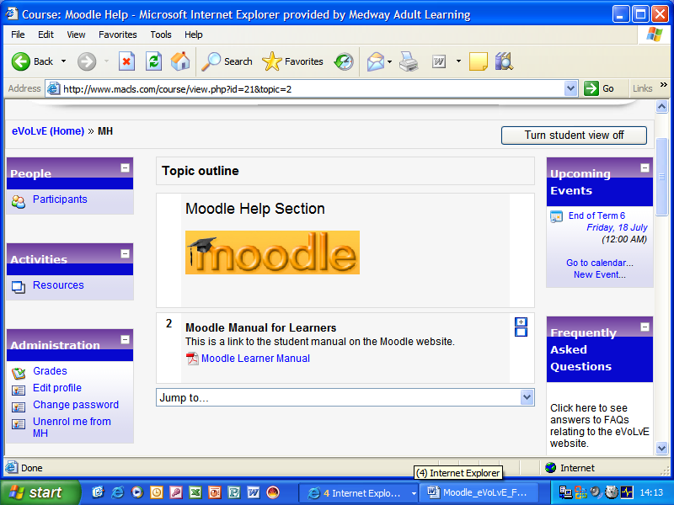

How do I find the area I need to access

Look for the My Courses block on the left-hand side of the screen. The areas you are already enrolled on are listed there. To look at all the areas in eVoLvE, click on All Courses at the bottom of the My Courses block. You will be able to access many areas without a key but some are only accessible by learners studying the relevant course with MCL.

I have deleted a resource and uploaded the new version, but when I click on it I can still see the old version

Your computer is holding the previous version in its temporary files. Other people will only see the newer version. You must delete all your temporary files to ensure you can see the new version. Do this by clicking on Tools, then Options in Internet Explorer, then Delete Files in the Temporary Internet Files section. Then you will need to restart your computer.

