How to add more Topic Boxes to your Course Area

All course areas come with a default of 10 topic boxes, usually this is plenty when displaying your course resources. However, some people find they quickly fill these topic boxes, use each topic box to display a weekly course timeline or feel they don’t need all ten topic boxes. This is where you can choose to either add more topic boxes or remove some. If you wish to do so, logged into your Moodle Evolve account and follow these instructions below.

Navigate to your course area, where you want to add or remove some topics boxes and select the Edit settings button under the Settings header in the left-hand column.

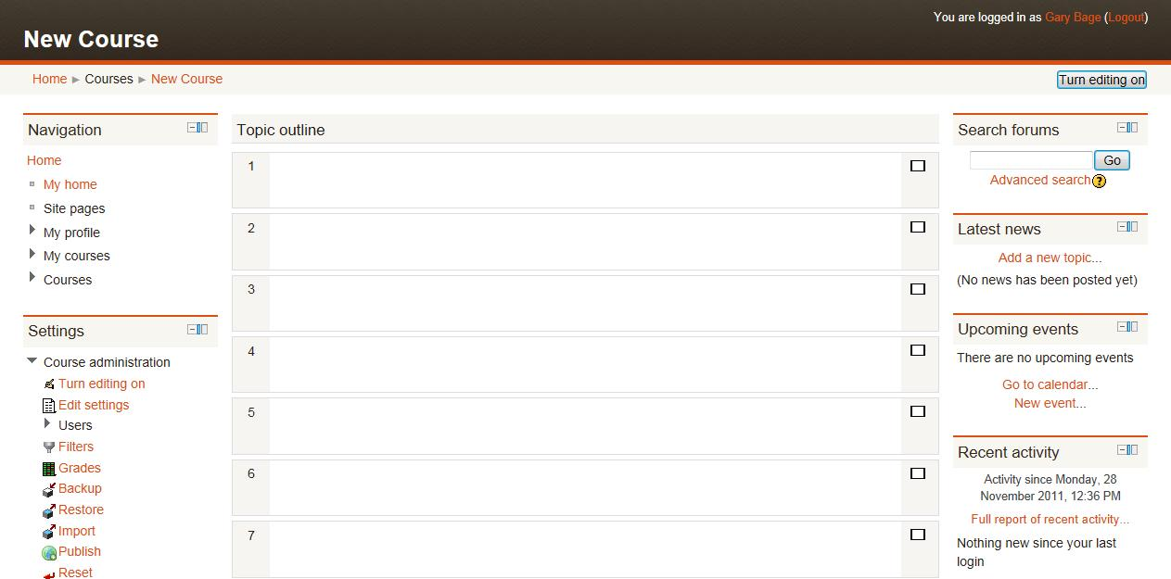

A new page will appear called Edit course settings. Select the drop-down box next to Number of weeks/topics and select the number of topic boxes you wish to display.

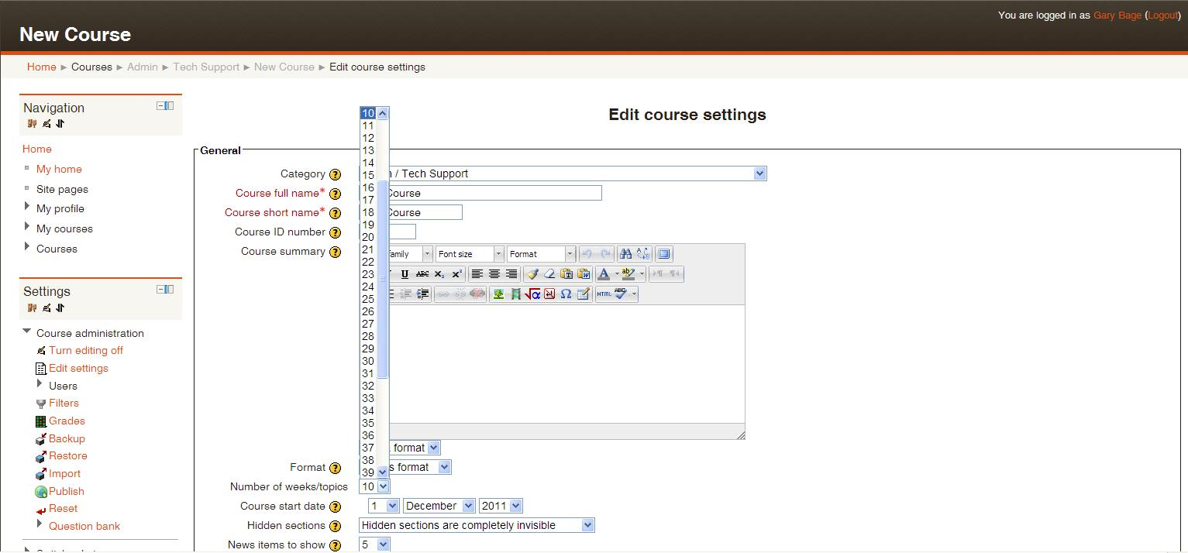

Now scroll down to the bottom of the page until you find the Save changes button and select it. This will save your course area’s new settings and return you to your course area.

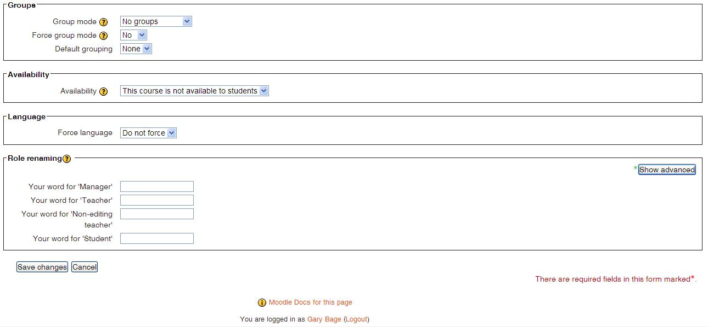

If you need any help, please contact our admin team on 01634 338424, enquiries@medway.gov.uk

