How to create a Picture Gallery on Moodle eVoLvE

Once you have logged into your Moodle Evolve account. If you wish to create a picture gallery in your course area, follow these instructions.

Navigate to your course area, where you want to create the picture gallery and select the Turn editing on button.

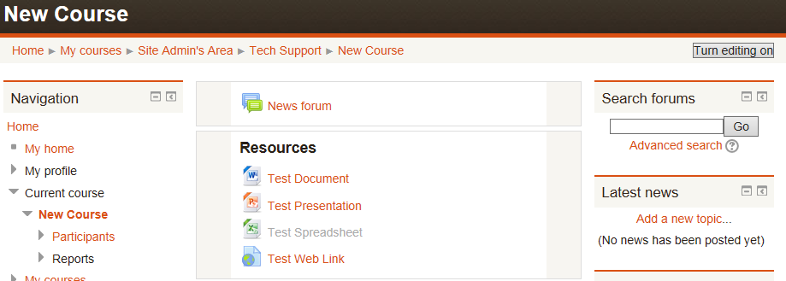

In the relevant topic box, click on Add a resource, then select Lightbox Gallery.

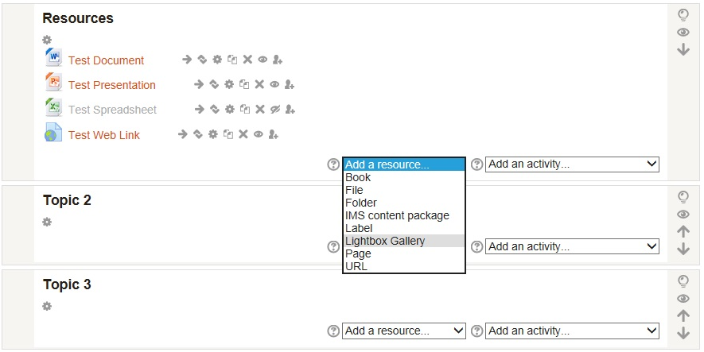

A new page will appear called Adding a new Lightbox Gallery. Enter a name and a brief description about the picture gallery into the relevant boxes to help explain the reason and use of the gallery to your learners.

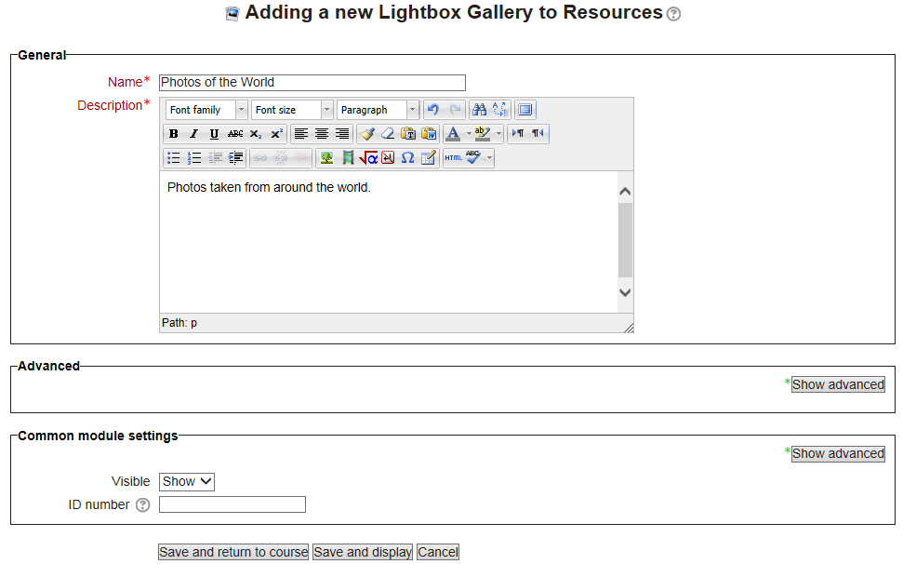

If you wish to adjust the number of pictures in one row, to display the picture’s full caption text or allow comments. Select the Show advanced button in the Advanced section. Once all is set, scroll down to the bottom of the page until you find the Save and return to course button and select it. This will save your gallery’s settings and will display it in your course area.

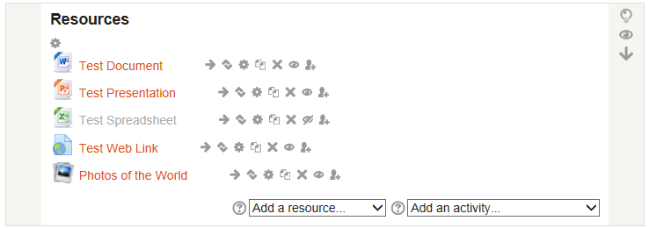

Once you have returned to your course area, select your gallery to open it. A new page will appear called Showing gallery: then your gallery name. To add pictures and photos to your gallery select the link underneath called Add images.

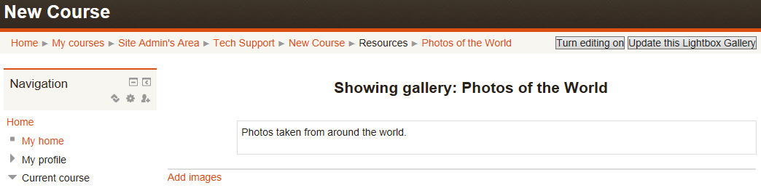

A new page will appear called Add Images, where you have the option of uploading the pictures and photos you wish to display in your gallery. Similar to when you have to upload a file, you have the option to select the Choose a file button and Browse your computer for the picture you wish to upload.

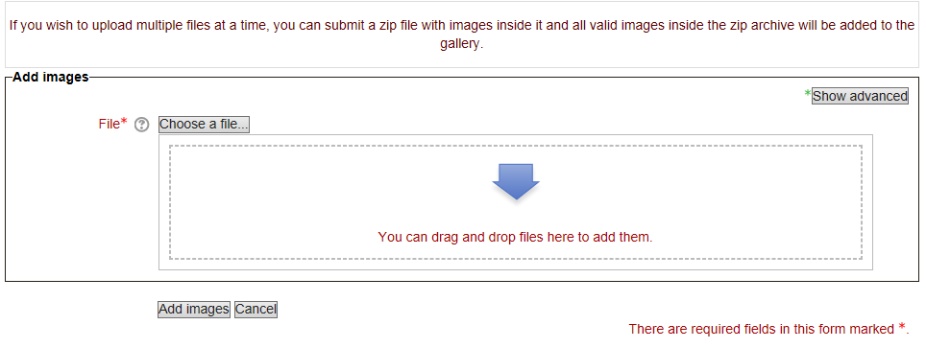

Or with certain Internet browsers (Google Chrome, Internet Explorer version 11, Safari and Firefox) you can now drag and drop files into the specified area following the instructions on the web page to upload pictures quicker. (Only available if the box displays a message reading ‘You can drag and drop files here to add them’).

Or if you are uploading multiple pictures at once, again following the instructions on the web page, you can zip the picture files into a Zip folder beforehand. Then when you browse your computer you can choose the Zip folder to upload all the pictures at once instead of individually.

Our instructions follow on from the first option of browsing your computer to choose the picture or zip folder that you wish to upload. Select the Choose a File button. A new window will open called File Picker. Select Upload a File in the left hand column. Then select the Browse button.

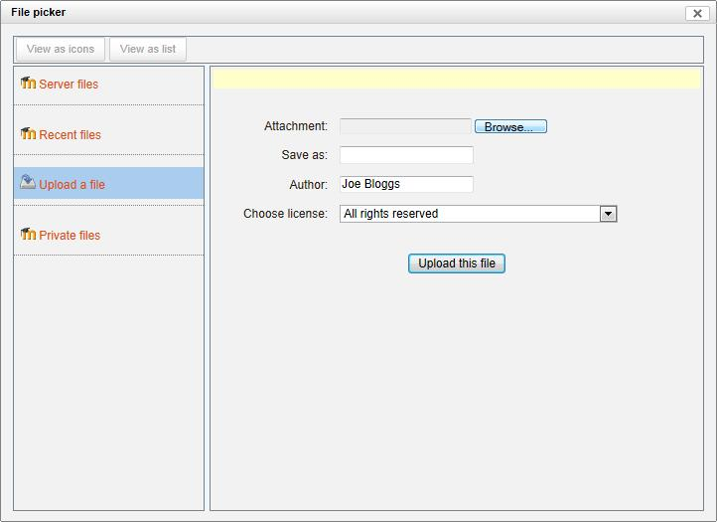

This will allow you to browse your computer folders for the picture you want to upload. Once you have located the picture, select the picture and click on the Open button.

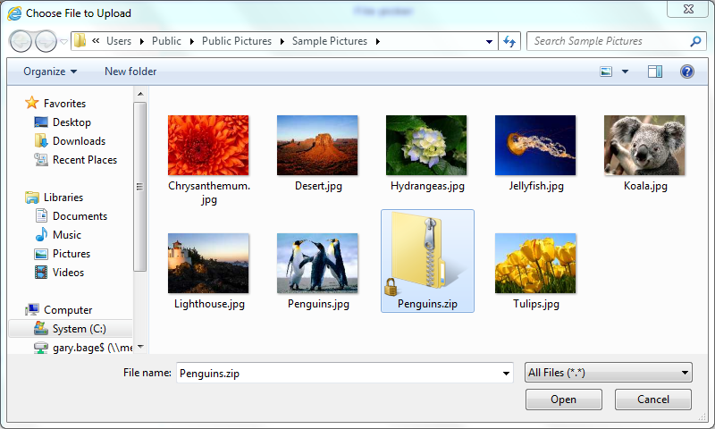

You will return to the File Picker page automatically and your file’s filename will appear in the attachment box. Now select the Upload this File button.

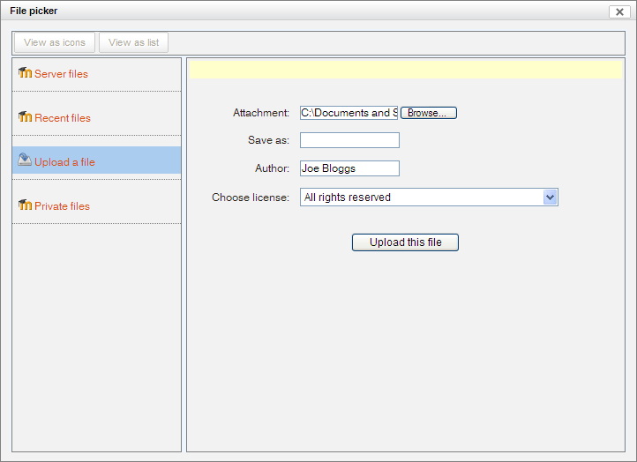

You’ll return to the Add images page, where you will see the selected picture file has appeared. Select the Add images button to confirm your selection and upload the picture into your Lightbox gallery.
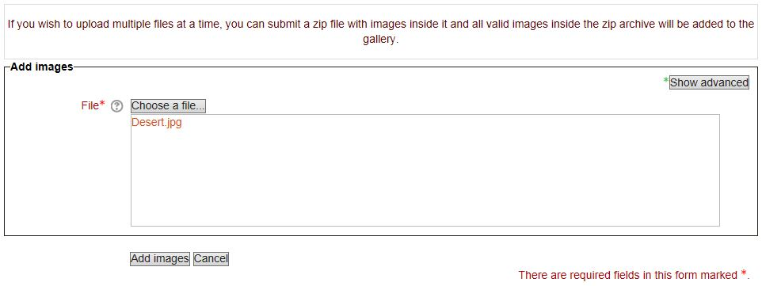
You’ll return to your gallery and be able to see your newly added picture. If you wish to continue adding more pictures, select the Add images link again and continue the same process as before.

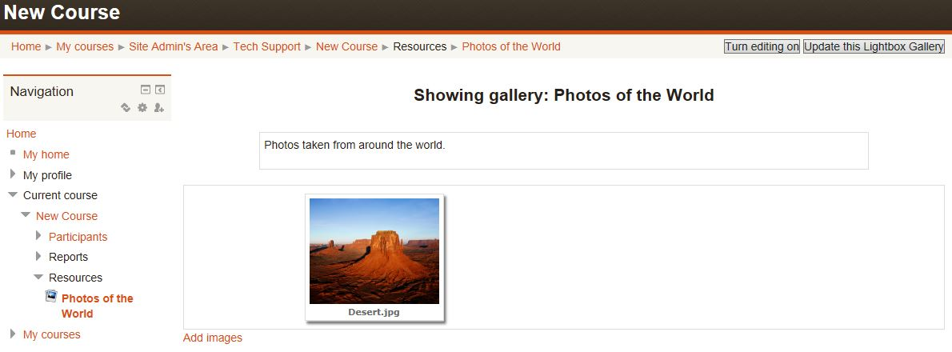

You also have the option to edit your pictures within the gallery, allowing you to create captions, edit the size or rotation of a picture and delete a picture if it’s no longer needed. To edit the pictures, select the Turn editing on button.

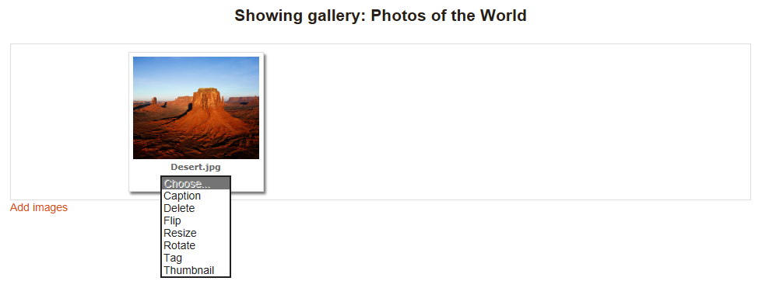
If you wish to edit any of your pictures, select the Choose button beneath the picture and use the drop-down menu that follows. You can only edit one picture at a time.

If you wish to edit more than one aspect of your picture, once you have selected one option from the drop-down menu, you enter the editing screen and all the drop-menu options are now added as Tabs at the top for you to switch between. However if you make a change remember to select the Update button to save the changes before moving on to another tab or back to your gallery, otherwise your changes will be lost.

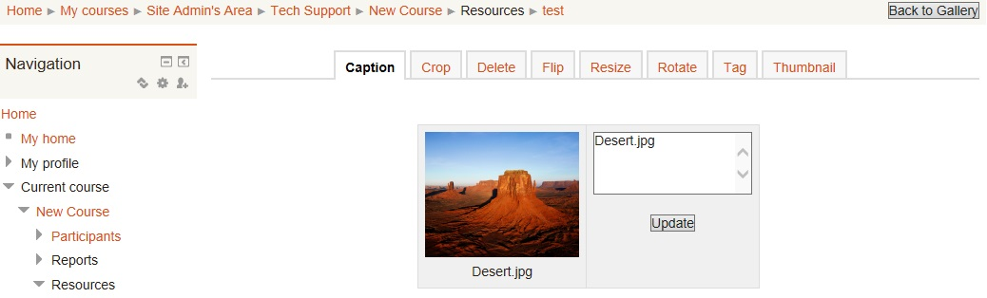
To return to your gallery, select the Back to Gallery button.

