INDIVIDUAL LEARNING PLAN (ILP)

Entry 1 ESOL

 | Name:  Learner No:  Venue:  Tutor: |  |  |  |  | Centre:  Course Title:  Course Code:  Start Date:  Expected End Date:
Sometimes your tutor might decide to capture your progress and achievement.
Please tick the boxes below to show consent:
1. I am happy for you to record my voice
2. I am happy for you to take photographs
3. I am happy for you to use a video
4. None of these

Learners Signature…………………………………………. Date…………………………
PAM Quality review of ILPs:

Date :

Initial:

Date:

Initial:

Moderation Meetings:

Date:  Present: | Outcome:

INITIAL ASSESSMENT SUMMARY

English language qualifications

Work experience past | Current
Previous Education

Length of time in UK

Languages spoken | Languages written
Starting point (level):

Listening and understanding | Speaking | Reading | Free Writing | ‘Learner Goals’  -barriers, previous work and training experience

Signature (Assessor) ________________________________________________

Signature (Learner) _________________________________________________

Date _________________________________________

Medway adult and community learning ESOL Established

DIAGNOSTIC GRID ENTRY 1
Learner name ___________________________________________ Consolidating

Emerging

LISTENING |  | SPEAKING
Understand simple questions and statements (e.g. How old are you?/ Your appointment is tomorrow). |  | Answer simple questions about myself (e.g. Where do you live?)
Listen and get the main point of listening tasks e.g. short explanations. |  | Ask simple questions about another person.
Follow single step instructions (e.g Put the pen on the table). |  | Give basic information on familiar subjects (e.g. how I feel today, food I like and don’t like).
Answer simple requests for information about myself (e.g. Do you have any children?) |  | Take part in a discussion with another person on a topic I understand.
Predict general meaning in everyday situations (e.g. what a receptionist and patient are talking about). |  | Use words I know and grammar I know in simple communication. (I’ve got 2 brothers, I don’t live in Strood).
Identify some details in a face to face situation.

Show I understand some short, common words, phrases and grammar.
Say when I don’t understand and ask for help.

Simplified descriptors, drawn from the ESOL Core Curriculum, adapted from Welcome to the UK, Learning Unlimited.

READING |  | WRITING
Recognise the purpose of and read a limited variety of short, familiar texts. |  | Write a short text (e.g. on a familiar or personal topic – myself, my house etc).
Use basic reading rules for English (e.g. from left to right |  | Use full stops and capital letters in sentences.
Read phrases and small groups of sentences. |  | Write simple sentences with words in correct order (I like football not I football like).
Recognise and understand a number of words. |  | Write short simple sentences that give meaning (e.g. I live in Chatham, I study English).
Read and understand social sight, high frequency words e.g. name, exit, closed. |  | Spell some personal words and words I know e.g. my name and address).
Recognise familiar letter combinations (e.g. ch/sh) |  | Write the alphabet in upper and lower case (ABC abc).
Recognise the alphabet in upper and lower case letters. (ABC abc). |  | Write numbers correctly.

Learner name _____________________Teacher name ________________________Date _____________ Course ___________

ENTRY 1 GRAMMAR CHECKLIST
TAKEN FROM THE ESOL CORE CURRICULUM

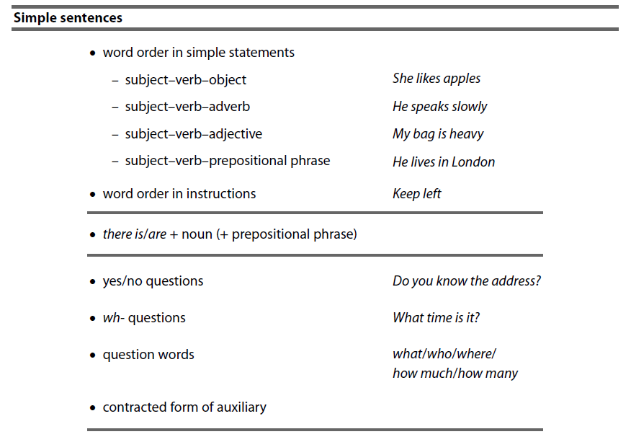
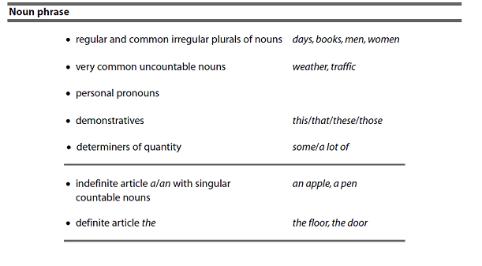



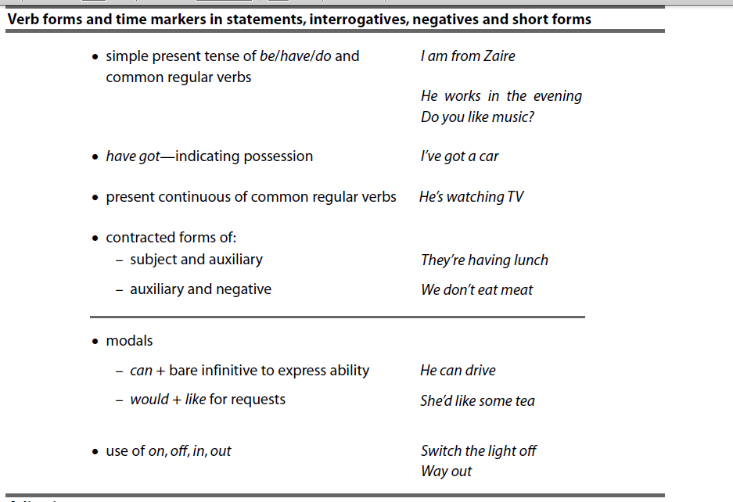

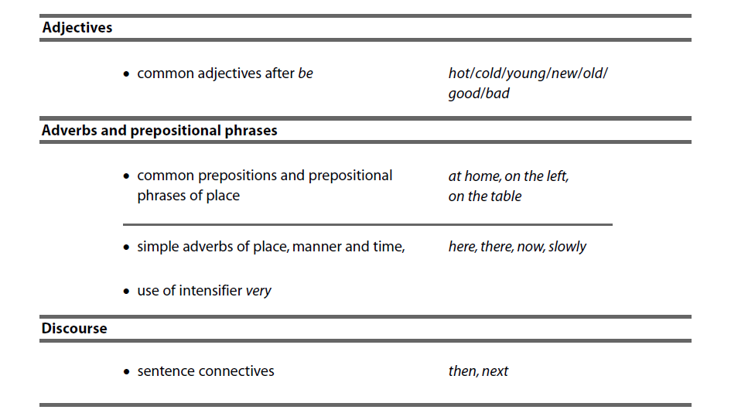
Learner Review and Tutor Feedback
Remember to state learning rather than activities completed
1. Review date:…………………

What have you learnt so far?:

Have you made progress from your aims?

Are you enjoying the learning? / Any other feedback?

Tutor Feedback:

Learner signature: Tutor signature:

1. Review date:…………………

What have you learnt so far?:

Have you made progress from your aims?

Are you enjoying the learning? / Any other feedback?

Tutor Feedback:

Learner signature: Tutor signature:
1. Review date:…………………

What have you learnt so far?:

Have you made progress from your aims?

Are you enjoying the learning? / Any other feedback?

Tutor Feedback:

Learner signature: Tutor signature:
1. Review date:…………………

What have you learnt so far?:

Have you made progress from your aims?

Are you enjoying the learning? / Any other feedback?

Tutor Feedback:

Learner signature: Tutor signature:

Learner signature .......................................................... Date ………………………

Tutor signature…………………………………………….. Date ………………………..

CM/ IQA Signature::…………………………………. Date: ………………………………….

