INDIVIDUAL LEARNING PLAN (ILP)

Entry 2 ESOL

 | Name:  Learner No:  Venue:  Tutor: |  |  |  |  | Centre:  Course Title:  Course Code:  Start Date:  Expected End Date:
Sometimes your tutor might decide to capture your progress and achievement.
Please tick the boxes below to show consent:
1. I am happy for you to record my voice
2. I am happy for you to take photographs
3. I am happy for you to use a video
4. None of these

Learners Signature……………………………………………. Date……………………….
PAM Quality review of ILPs:

Date :

Initial:

Date:

Initial:

Moderation Meetings:

Date:  Present: | Outcome:

INITIAL ASSESSMENT SUMMARY

English language qualifications

Work experience past | Current
Previous Education

Length of time in UK

Languages spoken | Languages written
Starting point (level):

Listening and understanding | Speaking | Reading | Free Writing | ‘Learner Goals’  -barriers, previous work and training experience

Signature (Assessor) ________________________________________________

Signature (Learner) _________________________________________________

Date _________________________________________

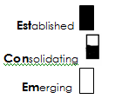
Medway adult and community learning ESOL
DIAGNOSTIC GRID ENTRY 2
Learner name ___________________________________________

LISTENING |  | SPEAKING
Show that I can understand in a limited range of listening situations (e.g. when listening to explanations, instructions or stories). |  | Begin or take part in straightforward conversations or discussions using English I am familiar with.
Listen and participate appropriately in familiar situations (e.g. at work, with an official, with friends and neighbours). |  | Use English in a range of everyday tasks such as asking about people’s feelings, making and responding to offers and requests, expressing my views.
Use my knowledge of simple grammar to help me understand and predict. |  | Help other people to understand me by using accurate grammar (e.g. using conjunctions and/but, modals such as could).
Indicate when I don’t understand and ask for clarification. |  | Express my feelings and opinions with confidence in a number of situations.
READING |  | WRITING
Read and understand the main points of simple texts with 2-3 paragraphs. |  | Create a simple text showing some awareness of format e.g. a simple letter or story.
Locate detail in simple texts of 2-3 paragraphs. |  | Construct simple and compound sentences using common conjunctions such as and/but.
Distinguish facts from opinions. |  | Write with legible and more fluent handwriting.
Recognise some common spelling patterns. |  | Spell most personal details correctly.
Use the context and letter-sound to read new words. |  | Spell most common familiar words correctly.
Use my knowledge of punctuation and grammar to help me read for meaning (e.g. capital letters and full stops).

Simplified descriptors, drawn from the ESOL Core Curriculum, adapted from Welcome to the UK, Learning Unlimited.

Learner name _____________________Teacher name ________________________Date _____________ Course ___________

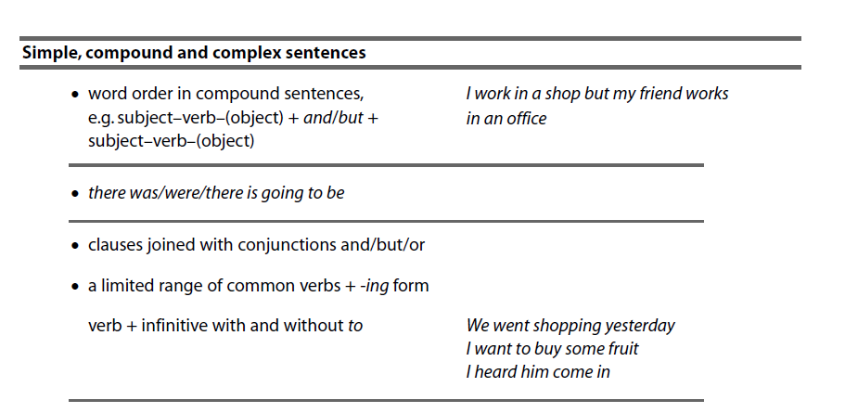

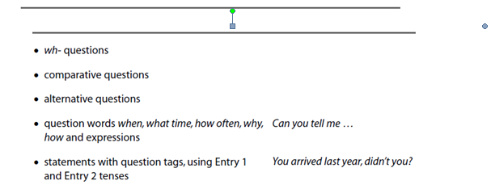
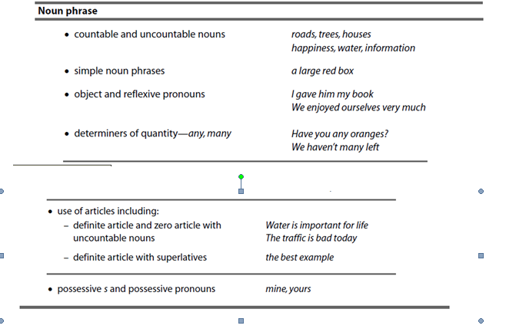
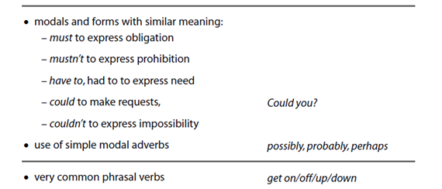

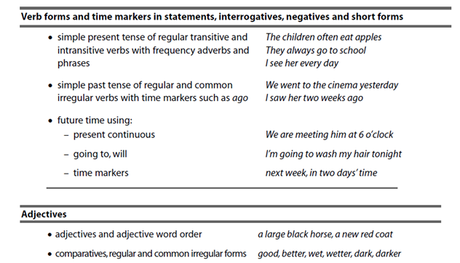
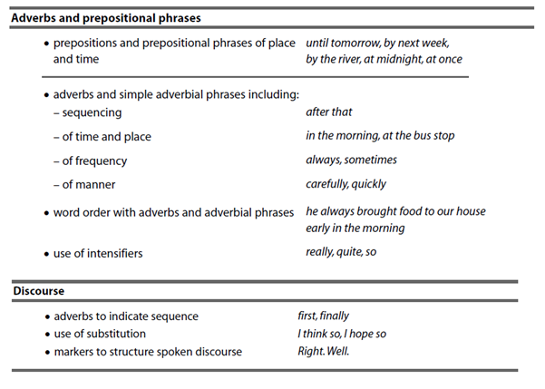

Learner Review and Tutor Feedback
Remember to state learning rather than activities completed
1. Review date:…………………

What have you learnt so far?:

Have you made progress from your aims?

Are you enjoying the learning? / Any other feedback?

Tutor Feedback:

Learner signature: Tutor signature:

1. Review date:…………………

What have you learnt so far?:

Have you made progress from your aims?

Are you enjoying the learning? / Any other feedback?

Tutor Feedback:

Learner signature: Tutor signature:
1. Review date:…………………

What have you learnt so far?:

Have you made progress from your aims?

Are you enjoying the learning? / Any other feedback?

Tutor Feedback:

Learner signature: Tutor signature:
1. Review date:…………………

What have you learnt so far?:

Have you made progress from your aims?

Are you enjoying the learning? / Any other feedback?

Tutor Feedback:

Learner signature: Tutor signature:

Learner signature .......................................................... Date ………………………

Tutor signature…………………………………………….. Date ………………………..

CM/ IQA Signature::…………………………………. Date: ………………………………….

