INDIVIDUAL LEARNING PLAN (ILP)

Entry 3 ESOL

 | Name:  Learner No:  Venue:  Tutor: |  |  |  |  | Centre:  Course Title:  Course Code:  Start Date:  Expected End Date:
Sometimes your tutor might decide to capture your progress and achievement.
Please tick the boxes below to show consent:
1. I am happy for you to record my voice
2. I am happy for you to take photographs
3. I am happy for you to use a video
4. None of these

Learners Signature…………………………………….……. Date………………………
PAM Quality review of ILPs:

Date :

Initial:

Date:

Initial:

Moderation Meetings:

Date:  Present: | Outcome:

INITIAL ASSESSMENT SUMMARY

English language qualifications

Work experience past | Current
Previous Education

Length of time in UK

Languages spoken | Languages written
Starting point (level):

Listening and understanding | Speaking | Reading | Free Writing | ‘Learner Goals’  -barriers, previous work and training experience

Signature (Assessor) ________________________________________________

Signature (Learner) _________________________________________________

Date _________________________________________

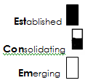

Medway adult and community learning ESOL
DIAGNOSTIC GRID ENTRY 3

Learner name ___________________________________________

SPEAKING |  | LISTENING
Confidently hold a conversation on familiar and new topics. |  | Show I can understand in a range of listening situations which include some new vocabulary.
Move between topics during a conversation and express my views. |  | Use my knowledge of stress, intonation and grammar to help me understand a speaker.
Hold a flowing conversation without much hesitation. |  | Use my understanding of situations to predict what people will say.
Deal with unpredictable language in conversation (e.g. ‘I’m sorry, I don’t quite understand…’) |  | Use some strategies to check my understanding (e.g. I think I need to apply online?)
Rephrase my language when someone doesn’t understand me. |  | Identify facts and opinions in familiar contexts.
Use non-verbal strategies to help someone understand me and to show I understand them.
Use a range of tenses to express past, present and future actions and events (e.g. I’ve lived in Medway for three years. I’m looking for English classes at the moment.)
Take turns to speak in discussion and be able to interrupt sensitively.

READING |  | WRITING
Read, understand and identify the main points in straightforward, longer texts. |  | Compose a variety of simple texts and show some understanding of paragraphs and layout (e.g. short report, simple instructions).
Find specific information in a range of texts. |  | Show some understanding of planning and drafting my writing.
Use my knowledge of some complex punctuation and sentence grammar to understand. |  | Check my writing for mistakes e.g. grammar and spelling.
Read and understand some specialist vocabulary e.g. words on forms. |  | Write some complex sentences showing correct use of basic grammar.
Use a variety of reading strategies to help myself read unfamiliar words. |  | Use a range of punctuation accurately (e.g. . ! “ ? Aa)
 |  | Use my knowledge of spelling to help me understand and to build new words (e.g. beauty – beautiful, sea/see).
 |  | Write legibly.
 |  | Spell common words correctly.
Simplified descriptors, drawn from the ESOL Core Curriculum, adapted from Welcome to the UK, Learning Unlimited

Simplified descriptors, drawn from the ESOL Core Curriculum, adapted from Welcome to the UK, Learning Unlimited.

Learner name _____________________Teacher name ________________________Date _____________ Course ___________

GRAMMAR CHECKLIST ENTRY 3
TAKEN FROM ESOL CORE CURRICULUM

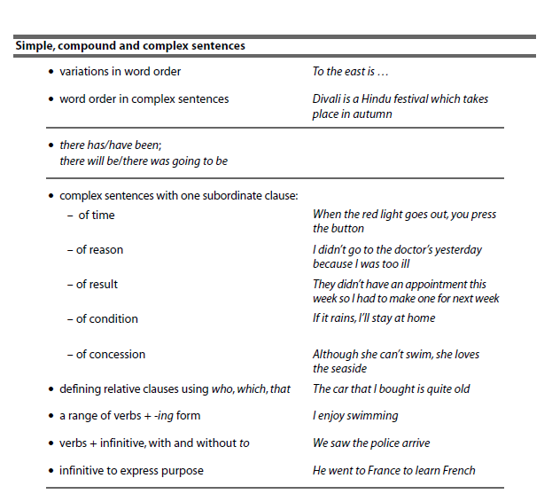
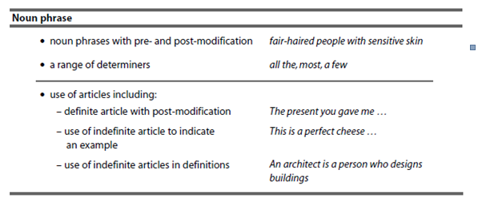

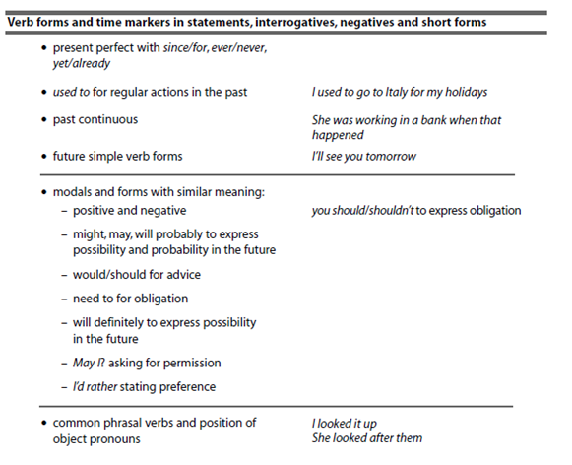

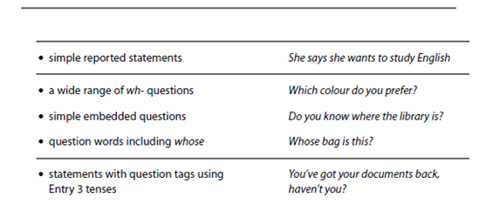

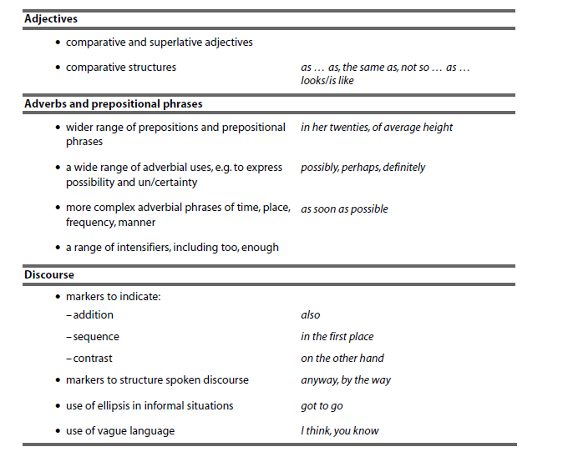

Learner Review and Tutor Feedback
Remember to state learning rather than activities completed
1. Review date:…………………

What have you learnt so far?:

Have you made progress from your aims?

Are you enjoying the learning? / Any other feedback?

Tutor Feedback:

Learner signature: Tutor signature:

1. Review date:…………………

What have you learnt so far?:

Have you made progress from your aims?

Are you enjoying the learning? / Any other feedback?

Tutor Feedback:

Learner signature: Tutor signature:
1. Review date:…………………

What have you learnt so far?:

Have you made progress from your aims?

Are you enjoying the learning? / Any other feedback?

Tutor Feedback:

Learner signature: Tutor signature:
1. Review date:…………………

What have you learnt so far?:

Have you made progress from your aims?

Are you enjoying the learning? / Any other feedback?

Tutor Feedback:

Learner signature: Tutor signature:

Learner signature .......................................................... Date ………………………

Tutor signature…………………………………………….. Date ………………………..

CM/ IQA Signature::…………………………………. Date: ………………………………….

