INDIVIDUAL LEARNING PLAN (ILP)

Level 1 ESOL

 | Name:  Learner No:  Venue:  Tutor: |  |  |  |  | Centre:  Course Title:  Course Code:  Start Date:  Expected End Date:
Sometimes your tutor might decide to capture your progress and achievement.
Please tick the boxes below to show consent:
1. I am happy for you to record my voice
2. I am happy for you to take photographs
3. I am happy for you to use a video
4. None of these

Learners Signature……………………………………………… Date………………………
PAM Quality review of ILPs:

Date :

Initial:

Date:

Initial:

Moderation Meetings:

Date:  Present: | Outcome:

INITIAL ASSESSMENT SUMMARY
English language qualifications

Work experience past | Current
Previous Education

Length of time in UK

Languages spoken | Languages written
Starting point (level):

Listening and understanding | Speaking | Reading | Free Writing | ‘Learner Goals’  -barriers, previous work and training experience

Signature (Assessor) ________________________________________________

Signature (Learner) _________________________________________________

Date _________________________________________

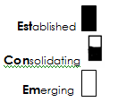
Medway adult and community learning ESOL
DIAGNOSTIC GRID LEVEL 1
Learner name ___________________________________________

LISTENING |  | SPEAKING
Follow extended speech and speakers who switch between topics in authentic and prepared listening situations. |  | Initiate and sustain a conversation with some unpredictable elements.
Respond confidently in complex situations, (e.g. show sympathy or express disapproval). |  | Speak comfortably and confidently at natural speed on a range of topics in situations within and outside my range of experience.
Confidently predict meaning from my understanding of context. |  | Express and give reasons for ideas and opinions (e.g. I felt very excited about coming to England – I’d read so much about London).
Confidently use a range of strategies to check or confirm my understanding |  | Interact confidently in a group which includes native speakers.
Differentiate between fact and opinion in a variety of contexts. |  | Use weak forms in connected speech (e.g. I haven’t got my own car yet).
Respond appropriately to a speaker’s style of language (register) and intonation. |  | Use stress and intonation to express feelings, opinions and attitudes.
Understand some variations in pronunciation and accents. |  | Use a wide range of basic and complex grammatical and lexical structures (e.g. tenses, conjunctions, reported speech, questions, instructions).
 |  | To be able to communicate clearly – when I make mistakes they do not stop people from understanding my main points.
Reading |  | Writing
Read, understand and interpret a wide range of different types of text. |  | Write continuous, well-organised text using paragraphs, markers and conjunctions (e.g. a letter, description, a report).
Confidently skim and scan texts to find and the main meaning and specific information. |  | Begin to show awareness of register appropriate to the task (e.g. a business letter, a creative story).
Predict meaning from context. |  | Begin to proof read for accuracy and meaning.
Understand the organisational features of a text to locate information (e.g. subheadings, paragraphs, charts). |  | Write compound and complex sentences using appropriate conjunctions and clauses.
Use knowledge of complex punctuation, grammar and spelling to assist my understanding of texts. |  | Use punctuation correctly to make my writing easier to understand.
Use a variety of reading strategies to help read and understand an increasing range of unfamiliar words. |  | Spell common and frequently used words correctly.
Simplified descriptors, drawn from the ESOL Core Curriculum, adapted from Welcome to the UK, Learning Unlimited.

Simplified descriptors, drawn from the ESOL Core Curriculum, adapted from Welcome to the UK, Learning Unlimited.

Learner name _____________________Teacher name ________________________Date _____________ Course ___________

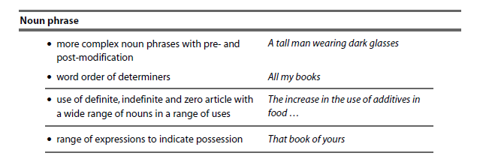
LEVEL 1 GRAMMAR CHECKLIST
TAKEN FROM THE ESOL CORE CURRICULUM

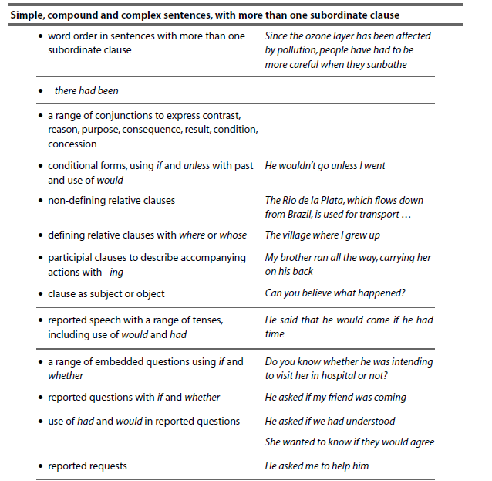
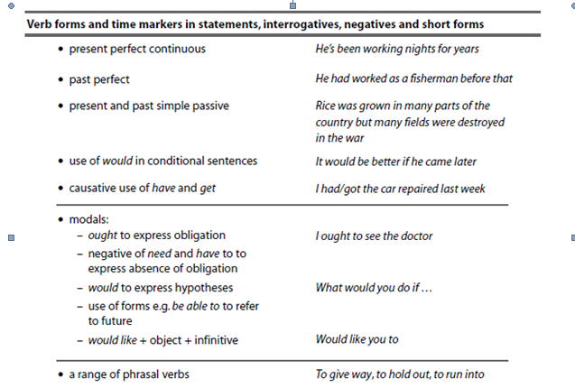

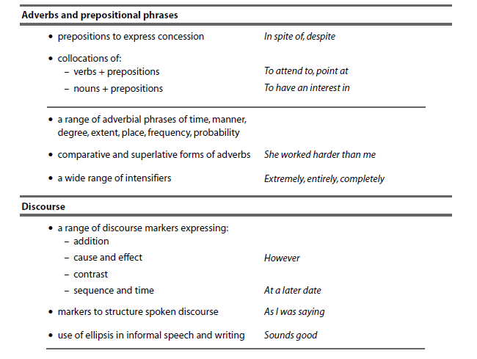

Learner Review and Tutor Feedback
Remember to state learning rather than activities completed
1. Review date:…………………

What have you learnt so far?:

Have you made progress from your aims?

Are you enjoying the learning? / Any other feedback?

Tutor Feedback:

Learner signature: Tutor signature:

1. Review date:…………………

What have you learnt so far?:

Have you made progress from your aims?

Are you enjoying the learning? / Any other feedback?

Tutor Feedback:

Learner signature: Tutor signature:
1. Review date:…………………

What have you learnt so far?:

Have you made progress from your aims?

Are you enjoying the learning? / Any other feedback?

Tutor Feedback:

Learner signature: Tutor signature:
1. Review date:…………………

What have you learnt so far?:

Have you made progress from your aims?

Are you enjoying the learning? / Any other feedback?

Tutor Feedback:

Learner signature: Tutor signature:

Learner signature .......................................................... Date ………………………

Tutor signature…………………………………………….. Date ………………………..

CM/ IQA Signature::…………………………………. Date: ………………………………….

