INDIVIDUAL LEARNING PLAN (ILP)

Level 2 ESOL

 | Name:  Learner No:  Venue:  Tutor: |  |  |  |  | Centre:  Course Title:  Course Code:  Start Date:  Expected End Date:
Sometimes your tutor might decide to capture your progress and achievement.
Please tick the boxes below to show consent:
1. I am happy for you to record my voice
2. I am happy for you to take photographs
3. I am happy for you to use a video
4. None of these

Learners Signature……………………………………..……… Date……………………..
PAM Quality review of ILPs:

Date :

Initial:

Date:

Initial:

Moderation Meetings:

Date:  Present: | Outcome:

INITIAL ASSESSMENT SUMMARY

English language qualifications

Work experience past | Current
Previous Education

Length of time in UK

Languages spoken | Languages written
Starting point (level):

Listening and understanding | Speaking | Reading | Free Writing | ‘Learner Goals’  -barriers, previous work and training experience

Signature (Assessor) ________________________________________________

Signature (Learner) _________________________________________________

Date _________________________________________

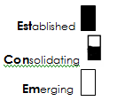
Medway adult and community learning ESOL
DIAGNOSTIC GRID LEVEL 2

Learner name ___________________________________________

LISTENING |  | SPEAKING
Follow extended speech and speakers who switch between topics in authentic and prepared listening situations. |  | Communicate confidently, accurately and fluently in a wide range of formal and social situations, adapting my speech to suit the audience, context and situation (e.g. adapt register, understand that direct disagreement is uncommon).
Lisen for and identify relevant information from extended explanations or presentations. |  | Interact confidently in groups that include native and non-native speakers of English, adapting my language as appropriate.
Recognise feelings and attitude, expressed overtly and/or through pitch, stress and intonation (e.g. ‘Typical, isn’t it!’ ‘Oh, really?’) |  | Take part in discussions, making clear, effective contributions that produce outcomes appropriate to the purpose and topic.
Confidently predict meaning from my understanding of context. |  | Initiate and sustain conversations with many unpredictable elements.
Use non-verbal and verbal strategies to respond appropriately in unexpected situations (e.g. to reassure, show sympathy, appear confident). |  | Use a wide range of complex grammatical and lexical structures (e.g. tenses, reported speech, phrasal verbs and idioms).
Confidently use a range of strategies to check or confirm my understanding |  | Use body language, stress, intonation and rhythm to convey my feelings, opinions and attitude, including using tentative rather than direct forms of disagreement in discussion.
Respond appropriately to a speaker’s style of language (register) and intonation.
Understand variations in pronunciation and regional accents.
Take part in discussions, making clear and effective contributions that produce outcomes appropriate to the purpose and topic.

Reading |  | Writing
Recognise and understand vocabulary associated with texts of different levels of formality, purpose, complexity and accessibility  . |  | Plan and draft my writing showing that I understand how much to write and how much detail to include.
Read and understand some technical vocabulary. |  | Use different types of paragraph structure and language features to aid sequencing and coherence.
Confidently skim and scan texts to find the main points and specific information. |  | Use format and structure to organise writing.
Use implicit and explicit grammatical knowledge to help follow meaning and judge the purposes of different type of text. |  | Use different styles of writing and apply formal or informal language appropriate to the purpose.
Use punctuation to help myself understand and interpret the meaning and purpose of texts. |  | Proof read and correct my own writing.
Identify the purpose of a wide range of texts and identify possible meaning which is not explicit. |  | Construct complex sentences.
Simplified descriptors, drawn from the ESOL Core Curriculum, adapted from Welcome to the UK, Learning Unlimited. |  | Use correct grammar in my writing (e.g. markers, relative clauses, reported speech, etc).
 |  | Use pronouns to avoid repetition and make my writing easier to read and understand.
 |  | Use a range of punctuation to help readers understand my writing (e.g. commas, apostrophes, brackets, quotation marks).
 |  | Use a range of strategies to spell accurately (e.g. word building, sound, knowledge of common endings, spelling rules).

Learner name _____________________Teacher name ________________________Date _____________ Course ___________

GRAMMAR CHECKLIST LEVEL 2
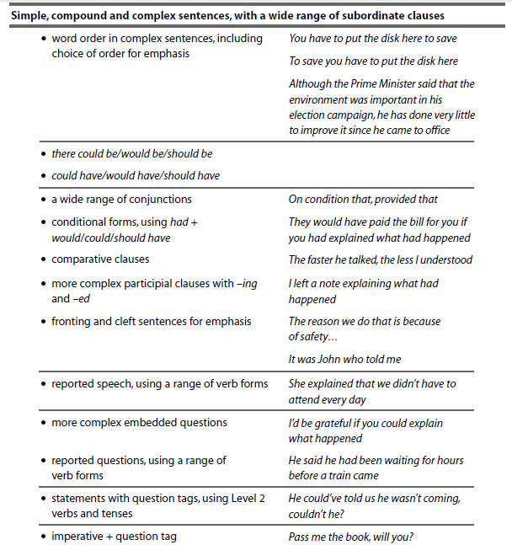
TAKEN FROM THE ESOL CORE CURRICULUM

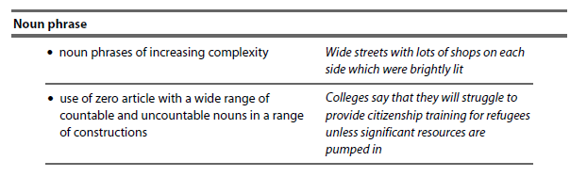

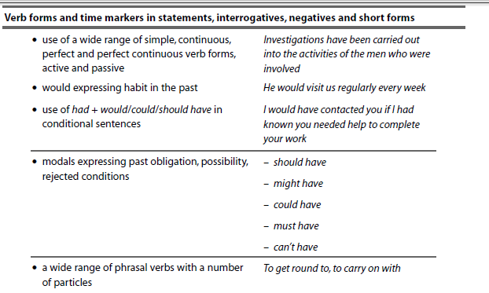

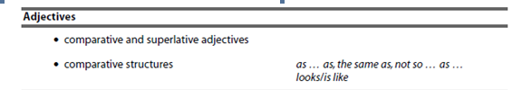

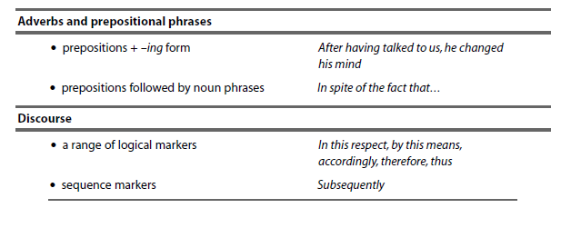

Learner Review and Tutor Feedback
Remember to state learning rather than activities completed
1. Review date:…………………

What have you learnt so far?:

Have you made progress from your aims?

Are you enjoying the learning? / Any other feedback?

Tutor Feedback:

Learner signature: Tutor signature:

1. Review date:…………………

What have you learnt so far?:

Have you made progress from your aims?

Are you enjoying the learning? / Any other feedback?

Tutor Feedback:

Learner signature: Tutor signature:
1. Review date:…………………

What have you learnt so far?:

Have you made progress from your aims?

Are you enjoying the learning? / Any other feedback?

Tutor Feedback:

Learner signature: Tutor signature:
1. Review date:…………………

What have you learnt so far?:

Have you made progress from your aims?

Are you enjoying the learning? / Any other feedback?

Tutor Feedback:

Learner signature: Tutor signature:

Learner signature .......................................................... Date ………………………

Tutor signature…………………………………………….. Date ………………………..

CM/ IQA Signature::…………………………………. Date: ………………………………….

