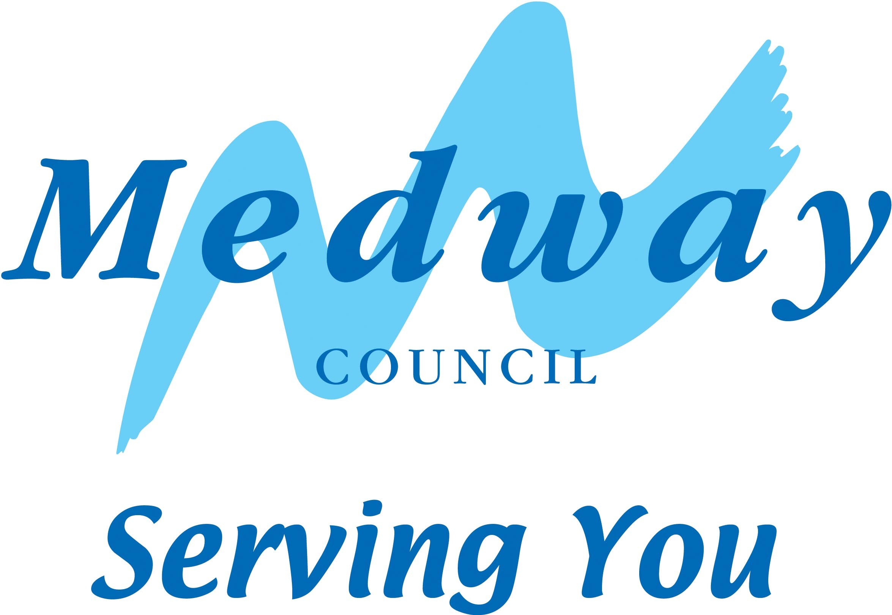  Course Code:  (Optional) |  | Course Title & Venue:
Name of Learner: Name of Tutor:
How do you feel about the following statements?  Please tick as appropriate: |  |  |  |  |  | Strongly  Agree |  | Agree |  |  |  | Disagree | Strongly  Disagree
The information I received before starting the course was useful (interviews, discussions, course outline etc)
The course is meeting my expectations
The initial assessment that I received ensured that I was on the best course for my needs
The course content is interesting and at the right level
The pace of the course is just right
The way the subject is taught is appropriate for me
I am getting the help I need in class
The tutor is approachable
The tutor gives me constructive feedback on my work
I feel valued as part of the group
I am happy with the support I am getting, the room and equipment (*comment on next page)
I am learning well and making good progress
I am enjoying the course
Do you feel safe when attending this course? |  |  |  |  |  | Yes |  | No, why? __________________________________________________________________________________
What are you liking MOST about this course?
What are you liking LEAST about this course?
How can we make this course better?
* If you are not happy with your support, the equipment or room, please give details:
General comments:

Signed – Learner: |  |  |  |  |  |  |  |  |  | Date:  Please Turn Over
About You
a | Attend Course  Daytime  Evening  Day & Evening |  | b | Gender  Male  Female  Transgender |  |  |  |  | c |  | Age  16 – 19  20 – 35  36 – 65  65 +
d | Ethnicity  White – English / Welsh / Scottish / Northern Irish / British  White – Irish  White – Gypsy or Irish Traveller  White – Any Other White Background  Mixed – Multiple Ethnic Group – White and Black Caribbean  Mixed – Multiple Ethnic Group – White and Black African  Mixed – Multiple Ethnic Group – White and Asian  Mixed – Multiple Ethnic Group – Any Other Mixed / Multiple Ethnic Background  Asian / Asian British – Indian  Asian / Asian British – Pakistani  Asian / Asian British – Bangladeshi  Asian / Asian British – Chinese  Asian / Asian British – Any Other Asian Background  Black / African / Caribbean / Black British – African  Black / African / Caribbean / Black British – Caribbean  Black / African / Caribbean / Black British – Any Other Black/African/Caribbean Background  Other Ethnic Group – Arab  Other Ethnic Group – Any Other Ethnic Group  Prefer not to answer
e | Do you have a Learning Difficulty?  Yes  No |  |  |  |  |  | f |  |  | Do you have a Disability?  Yes  No
g | Did you have 1:1 support or use any learning support equipment?  Yes - Please specify ………………………………………  No |  |  |  |  |  | h |  |  | Nationality  UK National  EU National  Other Nationality
Thank You for completing this form
All responses will be handled in the strictest confidence
The results will be analysed and used for quality improvement

