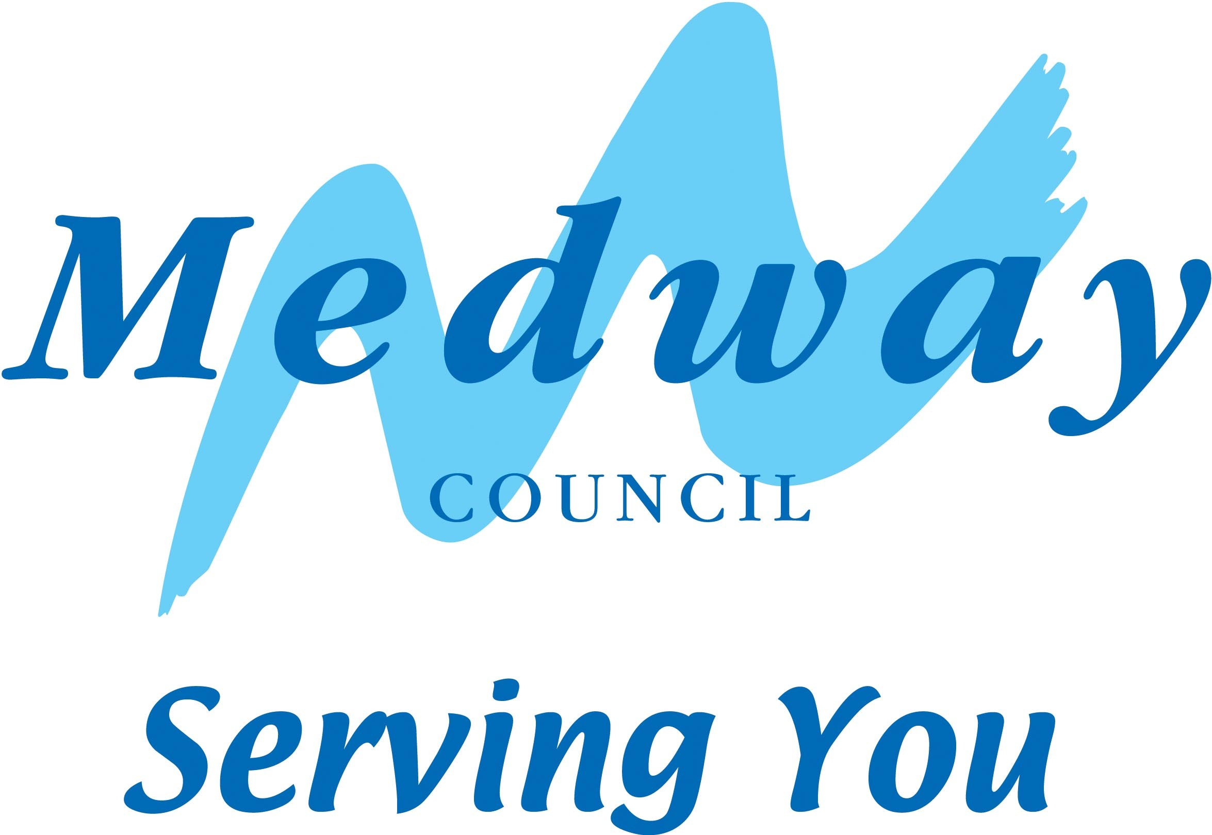  Course Code:  (Optional) | Course Title & Venue:
Name of Learner: Name of Tutor:
Start Date of Course: End Date of Course:
How satisfied are you with ... (see below) |  |  |  |  | Very Satisfied | Satisfied | Dissatisfied | Very Dissatisfied
... learning experience within the classroom?
... quality of the teaching/training?
... whole experience (including facilities/communication)?
... level of support given in the classroom? *
How well did this course meet your expectations? |  |  |  |  | Strongly Agree | Agree | Disagree | Strongly Disagree
My learning programme meets my individual needs
We had discussions about options re: my next learning step
I received equal treatment during all classes on my course
I received adequate feedback to my views and comments
I am now more confident in the subject/activity
The course has given me practical skills to use in the future
Did you feel safe when attending this course? |  |  |  |  | Yes | No, why? __________________________________________________________________________________
How likely will you undertake further learning in the future? |  |  |  |  | Very Likely | Likely | Unlikely | Very Unlikely
If ‘Very likely or Likely’ what will your next step be...? Please tick ✓all that apply
Continue studying this subject (next level) |  |  |  | Study with this tutor again (if possbile)
Enrol again with MACLS |  |  |  | Enrol with another College/Training Provider
Study a different subject |  |  |  | Study with my child (if applicable)
Other:
What did you like MOST about this course?
What did you like LEAST about this course?
How can we make this course better?
* If you were not happy with your support, the equipment or room, please give details:
General comments: |  |  | Please turn over
Signed – Learner: |  |  |  |  | Date:

About You
a | Attend Course  Daytime  Evening  Day & Evening | b | Gender  Male  Female  Transgender |  | c |  | Age  16 – 19  20 – 35  36 – 65  65 +
d | Ethnicity  White – English / Welsh / Scottish / Northern Irish / British  White – Irish  White – Gypsy or Irish Traveller  White – Any Other White Background  Mixed – Multiple Ethnic Group – White and Black Caribbean  Mixed – Multiple Ethnic Group – White and Black African  Mixed – Multiple Ethnic Group – White and Asian  Mixed – Multiple Ethnic Group – Any Other Mixed / Multiple Ethnic Background  Asian / Asian British – Indian  Asian / Asian British – Pakistani  Asian / Asian British – Bangladeshi  Asian / Asian British – Chinese  Asian / Asian British – Any Other Asian Background  Black / African / Caribbean / Black British – African  Black / African / Caribbean / Black British – Caribbean  Black / African / Caribbean / Black British – Any Other Black/African/Caribbean Background  Other Ethnic Group – Arab  Other Ethnic Group – Any Other Ethnic Group  Prefer not to answer
e | Do you have a Learning Difficulty?  Yes  No |  |  | f |  | Do you have a Disability?  Yes  No
g | Did you have 1:1 support or use any learning support equipment?  Yes - Please specify ………………………………………  No |  |  | h |  | Nationality  UK National  EU National  Other Nationality
Thank You for completing this form
All responses will be handled in the strictest confidence
The results will be analysed and used for quality improvement

