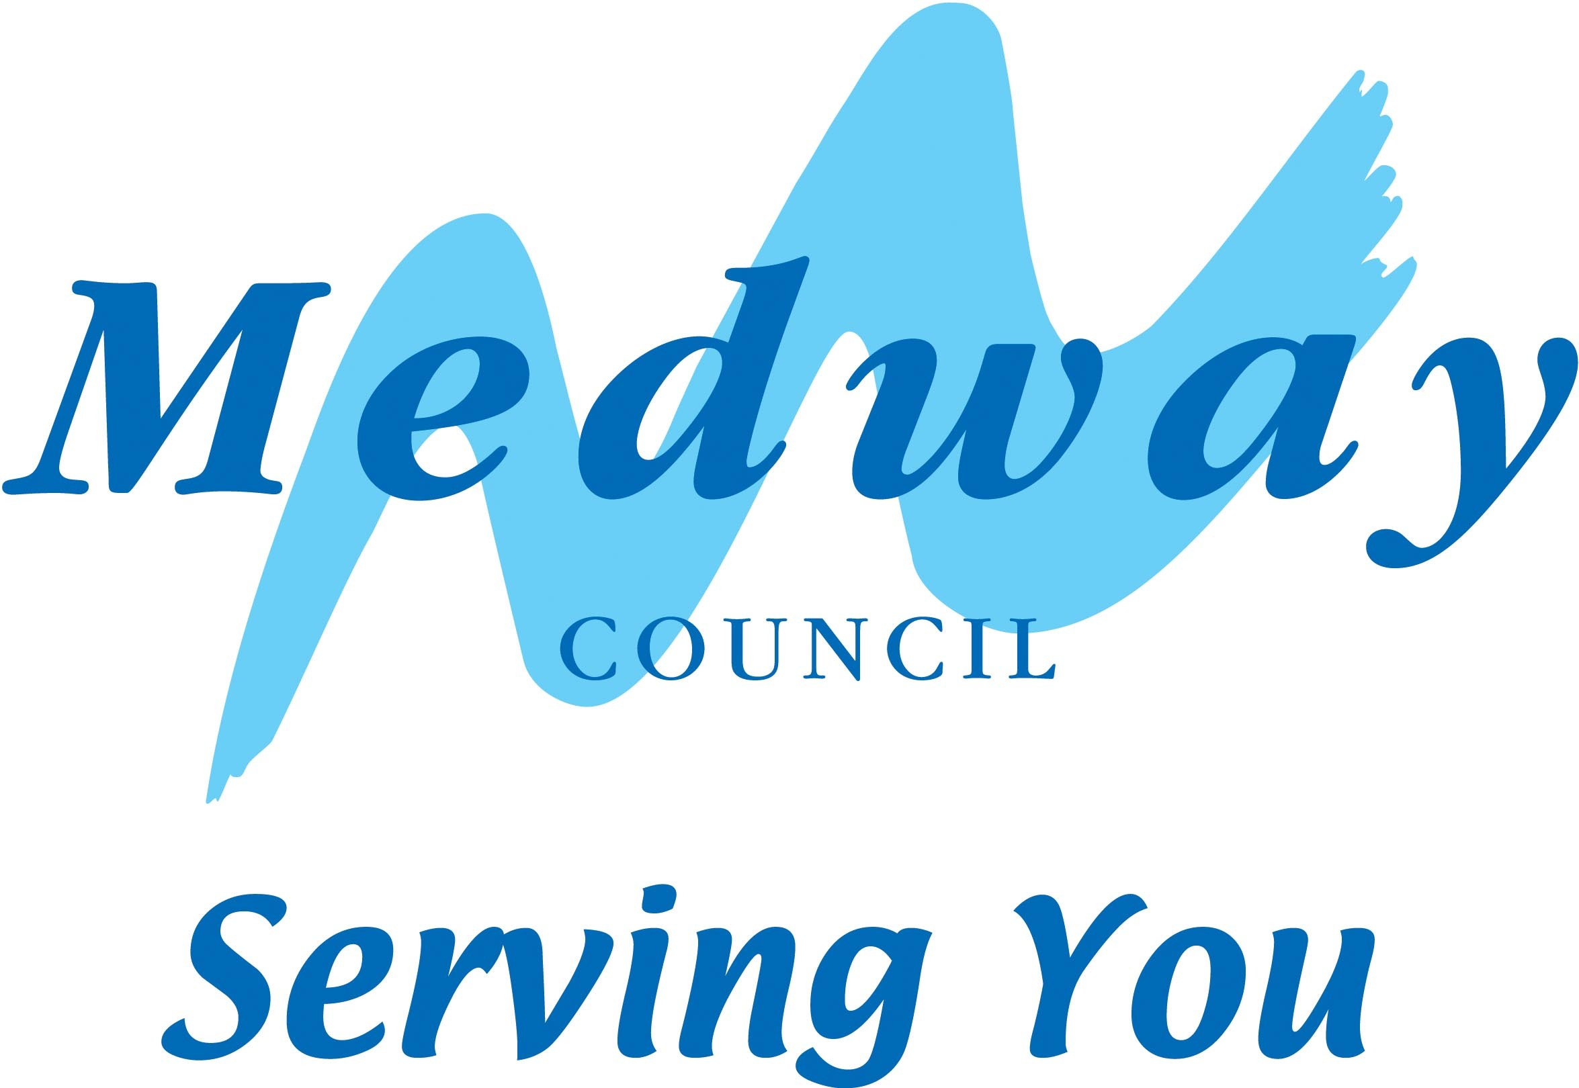

Observation of Teaching, Learning and Assessment Handbook

OTLA

Contents
OTLA Policy with Guidance notes | Page 1-6

Appendix
OTLA procedure and checklist for graded observations | 1
OTLA procedure and checklist for ungraded observations | 2
Notification to observee | 3
OTLA report form | 4
Tutor comment sheet and appeals procedure | 5
OTLA checklist | 6

OBSERVATION OF TEACHING, LEARNING and ASSESSMENT POLICY
Improvement of Practice

Medway Adult Community Learning Service is committed to providing high quality teaching, learning and assessment for its learners. It will achieve this through the implementation of a rigorous quality assurance process through a system of classroom observation and recommendations for improvement, and through a staff focussed quality improvement programme that recognises and supports the teaching staffs desire for continuous improvement.

Policy Aims

- To improve, monitor, and report on the quality of teaching, learning and assessment provided to learners and potential learners in the local community
- To develop a self-critical culture and an ethos of continuous improvement
- To embed a strong service culture across the organisation which places the learner at the heart of the system

In order to review and improve the quality of teaching, learning and assessment the Service:

- Undertakes an annual programme of classroom observations to review the practice of every member of the teaching staff and recommend improvements.

- Ensures reflection and self evaluation is practiced by all members of teaching staff

- Supports any recommendations for improvement by implementing and action plan for every member of the teaching staff

Policy implementation

Observation of Teaching, Learning and assessment

This process involves:

- Observing the classroom practice of every member of the teaching team conducted through a series of both graded and ungraded observations
- Making rigorous judgements about that practice, identifying strengths, weaknesses and areas for improvement through professional discussion or feedback as appropriate
- Where appropriate awarding a grade in accordance with the Ofsted 4 point scale
- Developing an Action Plan with clear targets
- Monitoring progress towards completion of the action plan

The cycle of this process starts in September each year and finishes when the reports and grades are all moderated and action plans completed.

Observation of Teaching, Learning and Assessment System

This is evidenced by the Observation of Teaching, Learning and assessment paperwork and moderated grades
The process papers include:
- those which are completed by members of teaching staff to show self evaluation
- those which are completed by observers to

report on observed practice
identify strengths, and areas for improvement
award a grade
recommend action for improvement
- those completed by members of teaching staff to evaluate the observation process
- those completed by the grade moderation panel

All members of teaching staff are observed annually and graded with action plans for improvement plus follow up visits in case of areas of concern.

Any existing member of staff that receives a grade 3 or 4 will be supported with developmental training to address the areas for improvement, and scheduled a re-observation within 6 weeks or as soon as practically possible to ensure the areas for improvement have been addressed.

New tutors are inducted into the process before they start teaching and receive a support visit (ungraded) in the first term of their working for the Service. A formal and graded observation will be conducted before the end of the probation period. In order for a new member of teaching staff to pass their probation period they will need to achieve at least a grade 2. Failure to achieve a grade 2 will result in either their probation period being extended up to a maximum of 6 months or failure of the probation period, this will be in line with Medway’s Probation policy 5.5.0 – 5.5.6.

MACL will encourage tutors to request an ungraded support observation to fine tune practice within their delivery.

Roles and responsibilities

The evidence is fed to Management for analysis and planning, Staff Development and SAR purposes and there are opportunities for feedback to tutors and learners

The Head of Performance and Standards is responsible for continually monitoring and amending the system in consultation with Programme Area Managers via the monthly quality review meetings. All recommendations are submitted to the Senior Management Team for their consideration

Review Process

The Observation of Teaching, Learning and Assessment Policy is reviewed annually for approval by the Senior Management Team. The process of review is overseen by the Head of Performance and Standards.

Guidance notes for Observers
The observation of teaching, learning and assessment (OTLA) is a key aspect of quality improvement. In September 2012, the new Common Inspection Framework set out the direction of travel for bringing learning back to centre stage.

This document seeks to offer brief guidance as to how this process can work effectively to help us raise the quality of teaching, learning and assessment.

Within this document the Tutor Being Observed is referred to as the observee.

The process of OTLA cannot raise quality if it takes place in a vacuum. The stated purpose of the MACLS process is to enable tutors to improve their practice in order to create better outcomes for learners. This can only happen if:

- Areas for improvement are accurately identified
- Clear guidance is given to observees about how to improve
- Monitoring and follow-up processes ensure that improvement has happened

Accurate identification of areas for improvement

In most cases, observation of classroom practice will take place for about 1 hour. In the case of outstanding or excellent lessons, it is possible to realise in about 10 minutes that you are seeing brilliant practice because of the tangible enthusiasm of all concerned – learning is obvious.

However, in the case of less than outstanding teaching it is often far more difficult to gauge from a slow or uninspiring hour where exactly things are going wrong or (perhaps more importantly) to support the observee effectively in getting things back on track (after the observation).

In many cases, poor teaching is the outcome of poor planning and preparation, poor knowledge of the learners and insufficient reflection by a tutor on what he/she could have done better. There may also be insufficient professional dialogue taking place between team members at (for example) departmental or one-to-one meetings.

To remedy this, we will be ensuring that all these aspects are taken into account and that the evaluation of teaching quality is not based on observation alone. The process will consist of three clear stages:

Stage One – preparation before the observation

Before observers even go into the classroom, they should prepare a file containing the following information:

- A copy of the Course Information Sheet – this can be downloaded from course finder or Aqua– try to gauge what the learners would be expecting from this course. Are there clear indications about learning outcomes and progression routes? Is there clear guidance about the additional work required for qualification courses? How good is the overall quality of the sheet?
- Copy of the course register – look for any patterns of attendance that would be open to question. Is the register clearly and correctly completed? Or is it messy and chaotic? Has the observee signed?
- Details of learners on the course (course analysis report print off from Aqua) – are there any 16-18 year-olds, learners who have self-declared learning difficulties or disabilities? What is the E&D profile (age, gender, BAME, LDD)? Do any of the learners have individual risk assessments?
- Moodle registration – have all learners been assigned logins for Moodle? Is there a page on Moodle for this course and/or the TBO? Are there any contents? Have any logins occurred? When was the last time that the TBO signed into Moodle (Jamie/Gary can supply this information). Try to form an impression about whether Moodle is being used effectively as a resource for this class.
- Copies of the risk assessment form for the class – has it been completed properly? Has it been signed by the TBO? Have appropriate arrangements been made for 16-18 or vulnerable adults? Are activity risk assessments noted (if applicable)? Are there any PEEPS?
- OTLA report for the last observation of this class/observee (if available) – what were the areas for improvement identified at the previous observation. Make a list of these points to check out during your observation. Have things improved?
- Action Plan or personal development plan from the last OTLA – has the observee acted upon previous recommendations? Has CPD taken place?
- Tutor feedback form from the last observation – did the observee complete one and return it as requested?
- PDR papers for the observee. What training has been identified? Has it taken place? Is there observee evaluation of the efficacy or the impact of the training?
- Any other papers e.g. learner surveys, RAS stats from previous year (if the observee was teaching the same course).

Following your analysis of this information, you should have a clear idea or at least an hypothesis of where the strengths and areas for improvement may lie.
Stage Two - The Observation of Teaching, Learning and Assessment

Effective and helpful classroom observation is based on a firm professional grasp of what outstanding teaching and learning involves. This information is available in the inspection handbook.

Outstanding teaching is the benchmark that MACLS is aiming for. Anything that falls short of outstanding must be compared with the expectations of outstanding in order to arrive at an action plan for improvement.

To support the observee and the Service, your report must be compiled using vocabulary that is meaningful and also positive – the observee should not have to wade through paragraphs of non-specific narrative trying to ascertain their strengths and areas for improvement.

Where there are areas for improvement we need the observee to feel that it is within their ability to address these shortcomings and turn them into strengths – not to be discouraged by a perception that the task is overwhelming.

It is important to prioritise the actions that are to be taken to improve, as leaving this to the observee puts them in a difficult position and may not result in the desired improvement. In other words the observer must make recommendations about which aspects should be followed up with CPD sessions or reading (e.g. from the Excellence Gateway). In recommending these actions you will be drawing on:
(a) Your own expertise as a manager of some experience within the sector and
(b) Your own knowledge of best practice.
Use the referral form to let the SMT know what is required.
Moderators must scrutinise the prioritisation given to the areas for improvement and also the suggested actions for improvement and satisfy themselves that these are appropriately robust and likely to lead to improvement. Be a critical friend.

Stage Three - Giving feedback to the tutor and agreeing a plan for improvement

Part of the process is to ensure that the observer, as a tutor and manager of some experience, leads the professional discussion with the observee and enables them to understand the required actions and the impact that these will have in improving the teaching.

The observee will see a copy of the written report first and it is important that this is clear and uses appropriate judgments based on the evidence seen. It is important that during the discussion, the observee is invited to identify and articulate some of the areas for improvement in their own terms. If a tutor fails to “own” the weaknesses then improvement will be much harder to secure.

Make sure there is a clear link between the areas for improvement and the proposed actions in the action plan at the back. (This does not mean a simple cut-and-paste exercise as they need to be different and prioritised).

Make the tutor central to the process of improvement by ensuring that they reflect on the process and the outcomes and that they record these reflections on the tutor feedback form. Completion and return of these forms to date is very low and this demonstrates a break in the loop of the process. We need to aim for 100% closure.

Additional work will take place during standardisation meetings to collate some service standards on the expected quality for tutor feedback.

It is important that the tutor is aware that the OTLA process results in a grade that is (on the one hand) stand-alone for that lesson but that also, will feed into the larger loop that is the PDR process. Both the stand-alone grade and the overall effectiveness (as demonstrated by PDR) may affect the tutor’s future with MACLS– in both positive and negative ways.

