August 2013

Medway Council - Business Support Department
Medway Adult and Community Learning Service
Rochester Centre
Eastgate
Rochester
Kent ME1 1EW
Telephone: 01634 33 84 00
Facsimile: 01634 33 84 01

Assistant Director: Tricia Palmer

Medway Adult and Community Learning Service - Rochester centre

The Management responsible for Medway Adult and Community Learning Service will endeavour, as far as is reasonably practicable, to assure the health, safety and well-being of staff, tutors, learners and visitors to our premises. All staff are aware of their responsibilities to ensure their safety and that of others they work with by following any safe systems of work that have been set reporting hazards or unsafe working practices, using safety equipment provided to them and co-operating with their employer.

This statement will be displayed in all teaching and public areas, and will be reviewed and updated on a yearly basis, or more regularly if changes take place.

All staff have a responsibility to report any hazard or dangerous occurrence to the caretakers or a member of the management team.

Visitors, tutors and learners are invited to report any known hazard or dangerous occurrence to a member of staff within the centre.

The caretaker will monitor facilities and keep records of such and ensure that first aid boxes are correctly stocked.

Fire regulations and procedures will be clearly displayed. The caretaker will check fire alarms weekly. Regular fire drills will take place.

All staff working in the centre will be made aware of the Health and Safety at Work Act 1974, and of their responsibilities in their working areas and, if they teach, for passing on this information to their learners.

All accidents and incidents should be reported IMMEDIATELY to a member of the management team or caretaker.

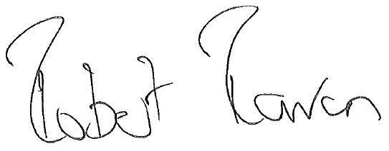

Robert Raven
Interim Head of Service

