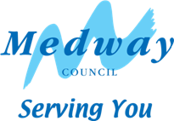
Please contact:
Your ref:
Our ref:
Date:

Medway Council - Business Support Department
Medway Adult and Community Learning Service
Rochester Centre
Eastgate
ROCHESTER
Kent ME1 1EW
Telephone: 01634 33 84 00
Facsimile: 01634 33 84 03
e-mail: mcladmin@medway.gov.uk

Assistant Director: Tricia Palmer

Dear

I am sorry you have been unable to attend class recently; I have tried contacting you by phone but have had no success.

I am concerned that if you miss too many sessions you may find it difficult to catch up, which could in turn leave you feeling uncomfortable in the class.

If there is a problem preventing you from attending please let us know, as we may be able to help.

When phoning in please be sure to quote your course number and or the day and title of the course.

I hope to see you in the near future.

Yours sincerely

Tutor

Course Number:

Course:

