Safer Working, Safer Learning

Staff Training Workbook

Medway Adult Community Learning Service
2013

Name: |  | Date:

Document Version History

Date | Version Number | Author | Notes
4 July 2012 | 0.0a | Jude Sach
18 Sept 2012 | 0.0b | Jude Sach | Addition of H&S Activities
29 Nov 2013 | 0.0c | Hermi Rathour | Update workbook

Table of Contents

Document Version History 2
Table of Contents 3
Introduction 4
Intended Learning Outcomes 5
Why are we doing this? 5
Activity: Definition of Adult at Risk 5
Activity: Whose responsibility is it? 6
What is Acceptable Behaviour? 8
Safeguarding People from Abuse 12
Activity: Definition of Abuse 12
Safeguarding within MACLS 12
Creating an Effective and Safe Learning Environment 13
Safeguarding Case Studies 16
Scenario One – Our Recommendations 18
Scenario Two – Our Recommendations 19
Scenario Three – Our Recommendations 20
The Five Rs of Safeguarding 21
In an Emergency… 21
Important Information 22
My Programme Area Manager/Leader(s) 22
Safeguarding Designated Persons at MACLS 22
The address of the centre(s) I work in 22
Answers 22

Introduction

The aim of this workbook is to support you learning and to act as an aide memoir. Please use it in conjunction with the Safer Working, Safer Learning staff training package available on Moodle for self-study or as part of the classroom-based course.

You should retain this workbook after completion as a record of training and for reference.

Assessment

There will be a short test at the end of the training to check your understanding. This can be taken as a paper-based test or online. Completed paper-based tests should be submitted to Jerri Burden, Student Services Manager. Completed online tests will automatically be submitted to Jerri.

Intended Learning Outcomes

The aim of this learning package is to provide key information on creating a safe working and learning environment for all staff and learners, including:
- Safeguarding Adults at Risk
- Health & Safety in the Workplace

Why are we doing this?

MACLS is fully committed to ensuring that all of its learners are able to enjoy their learning free from any form of bullying, harassment, abuse or discrimination in a safe and conducive learning environment. It is particularly concerned with the safeguarding of vulnerable adults (now known in MACLS as Adults at Risk), young people and children and as such, has rigorous safeguarding procedures across the organisation.

Activity: Definition of Adult at Risk

What is the definition of an Adult at Risk?

Activity: Whose responsibility is it?

A child or an Adult at Risk will come into contact with all sorts of people in their daily lives. Here are some examples. Which ones would you say have some responsibility to look out for their safety and well-being?

Please circle your answers before moving on to the next slide.

Parents or carers | Yes/No
The emergency services | Yes/No
Social services personnel | Yes/No
Teachers and lecturers | Yes/No
Administrative and support staff at school or adult education | Yes/No
Friends, neighbours and colleagues | Yes/No
Health service personnel | Yes/No
Strangers and passers-by | Yes/No

Now compare your answers with ours.

Are there any that surprised you? Why?
Make a note of your thoughts in the box below.

Remember…

You needn’t feel overwhelmed by this shared responsibility. On the one hand, it just means recognising when someone might be in trouble, and passing your concerns onto the right person. But, more than that, it means maintaining a professional and supportive relationship with the children and Adults at Risk with whom you come into contact.

After all, we don’t know to whom a child or adult at risk might turn when they’re in need. We don’t know who might be the person to spot that something’s wrong. It could be the librarian or the lollipop lady (or man). It might be a friendly cleaner they walk past every day, or it might be you.

What is Acceptable Behaviour?


First of all, do you think it’s right for staff to have any physical contact at all with learners, such as shaking hands or tapping them on the shoulder?

- Acceptable
- Unacceptable

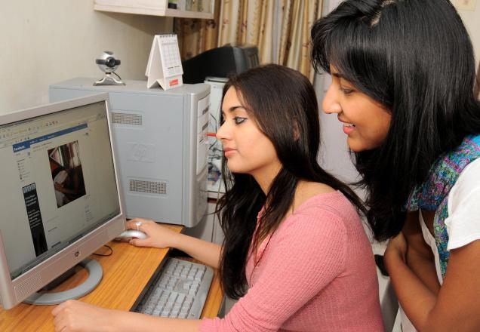
How about a staff member adding a learner as a personal friend on a social networking website?

- Acceptable
- Unacceptable


What about a member of staff taking a 17-year-old learner to a party, gym or club?

- Acceptable
- Unacceptable

Compare your answers with ours on the next page

Physical Contact with Learners…
Most people are comfortable with shaking hands as a conventional greeting. This kind of customary physical contact is unlikely to cause any offence. Of course, different cultures have their own conventions, so there may be the odd awkward moment, but this is nothing to worry about in a safeguarding context.

Social Networking…
The internet provides all sorts of useful ways for learners and staff to contact and interact with each other, both for learning and general support. However, it’s important to keep this contact on a professional footing, and to avoid befriending learners online. The same goes for phones – learners shouldn’t have your personal phone number or be able to contact you socially out of adult education hours.

Socialising with Young Learners…
The situation here is even clearer when it comes to parties, clubs or social gatherings. Socialising with young learners in this way is questionable at best, and depending on the circumstances, could even lead to disciplinary action and ultimately dismissal.

Question: What are your thoughts about socialising with Adult Learners?

 | How about a member of staff giving a learner a lift home, with no-one else in the car?  - Acceptable  - Unacceptable
 | How would you feel about a member of staff making sexual remarks and jokes about learners to fellow members of staff?  - Acceptable  - Unacceptable
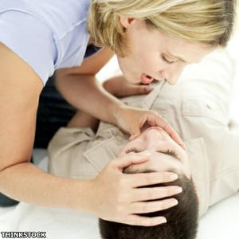 | Finally, what about a member of staff touching a learner – with their permission, but possibly quite intimately – in order to administer first aid?  - Acceptable  - Unacceptable

Compare your answers to ours on the next page.
Giving a Learner a Lift…
You might well be inclined to offer a learner a lift home with the very best of intentions, especially in poor weather. That doesn’t change the fact that it’s open to misinterpretation, by the learner and others. We’d strongly recommend avoiding this situation where possible, or at least ensuring others are in the car with you.

Remarks and Jokes…
What’s definitely unacceptable is for any staff member to make sexual remarks and jokes about learners. In fact, this sort of behaviour is often a strategy adopted by abusers to test the attitudes of others and gain their approval. If you have genuine concerns about the behaviour of a colleague, you shouldn’t hesitate to report them – you may feel uncomfortable doing this, but remember, your first priority has to be the safety of learners.

Giving First Aid…
What’s acceptable or unacceptable will vary according to the circumstances. In situations requiring first aid, for example, most people would accept that close physical contact might be required.

In a nutshell, it all comes down to professionalism and trust. In other words, we all need to behave professionally, and not take advantage of the position of trust we’re in.

Safeguarding People from Abuse

Activity: Definition of Abuse

What is the definition of Abuse?

How might you become aware of abuse?
You may see or hear something
- An adult at risk may tell you about apparent abuse
- A friend, family member or somebody else may tell you something that causes you concern
- You may notice injuries or physical signs that cause you concern
- You may notice either the victim or abuser behaving in a way that alerts you that something may be wrong

Safeguarding within MACLS

All staff in the Service have a responsibility to ensure that children, young people and Adults at Risk are safe from all types of harm. An open and supportive culture promotes the safety and well-being of everyone within the Service so that:
- Learners can progress and achieve
- Everyone is assured that their welfare is of high priority

Safeguarding means taking action if you think somebody is being abused or neglected

Creating an Effective and Safe Learning Environment

Question: Which of these is the top cause of accidents in the workplace?*

- Manual Handling
- Working at Height
- Getting Caught in Machinery
- Slips, Trips and Falls
- Chemical Spills (COSHH)
- Medical Emergencies

*You can check your answer on the back page of this workbook.

As a tutor, consider the types of accident that are most likely in your teaching room – it will vary for each subject area and, of course, by each topic.

List below some of the key hazards that you and your learners could be faced with and some potential ways to reduce the risk involved:
Hazard | How likely is this to happen? | What steps could you take to reduce or manage the risk?

Question: Why is encouraging learner engagement important in creating a safeguarded learning environment?

Creating a Safe Learning Environment

Question: Who is responsible for Health and Safety at work?

Question: What is Risk Assessment?

Question: What is Risk Assessment?

Question: Who is responsible for Risk Assessment in classes and for learners?

What can you do to help keep learners safe?

Give a thorough induction to learners on health and safety
Adhere to MACLS policies on safeguarding e.g. referring to the ‘safeguarding card’ for reporting concerns
Carry out risk assessments for children or vulnerable people – find out how to do this from your line manager if you have never done it before (See Safeguarding Risk Assessment Form)
Encourage learners to walk together to car parks – especially when dark
Make sure key staff are informed of learners with health problems
Set and discuss class rules including bullying and cyber-bullying
Be clear how to refer if you have concerns about an individual’s safety AND DO IT!
Ensure that all notices relating to safety and safeguarding are clearly displayed and updated regularly

Safeguarding Case Studies

Scenario One
A colleague tells you he thinks a learner called Ruth has ‘a bit of a crush on him’ and shows you some email messages that Ruth has sent to his personal email address. What would you do?
Yes/No
Tell him not to worry. He should be flattered.
Advise him not to give out personal contact details in future to avoid issues like this.
Call the police.
Contact a Safeguarding Designated Person if you’re unsure what to do.

Scenario Two
Amy, a learner aged 16, tells you she’s pregnant and wants information about a termination. She tells you this is the second time in a year she’s been pregnant and she had a termination about six months ago. She asks you not to tell he mum because, last time she was pregnant, her mum ‘went ballistic’. What would you do?
Yes/No
Call the police. Amy is in immediate danger and needs to be taken into care.
Alert a Designated Person for Safeguarding. This is a safeguarding issue.
Talk to Amy’s mother to find out if she is being sufficiently supportive.
Have a quiet chat with Amy’s friends to find out if there are any underlying problems behind her behaviour.

Scenario Three
Tom, a 17-year-old learner, tells you he’s not getting along with other learners in his group and that he feels threatened and intimidated by them. He has discussed this situation with the tutor but nothing has been done about it. He tells you he’s very unhappy and can’t see a future for himself. What would you do?
Yes/No
Contact a Designated Person for Safeguarding, especially if Tom seems in real distress, or seems at risk of harming himself
Ask Tom who the main culprits are in his group, and offer to speak to them
Offer to talk to Tom’s tutor, as group dynamics falls within the tutor’s responsibility
Encourage Tom to snap out of it and stand up for himself

Scenario One – Our Recommendations

A colleague tells you he thinks a learner called Ruth has ‘a bit of a crush on him’ and shows you some email messages that Ruth has sent to his personal email address.

What would you do?
 | Yes/No
Tell him not to worry. He should be flattered. | No
Advise him not to give out personal contact details in future to avoid issues like this. | Yes
Call the police. | No
Contact a Safeguarding Designated Person if you’re unsure what to do. | Yes

Why?
If Ruth is emailing your colleague using his personal email address, then it raises questions about why he’s chosen to make this sort of private communication possible. As ever, if you’re unsure about the action you should take, contact a Designated Person for Safeguarding.

Scenario Two – Our Recommendations

Amy, a learner aged 16, tells you she’s pregnant and wants information about a termination. She tells you this is the second time in a year she’s been pregnant and she had a termination about six months ago. She asks you not to tell her mum because, last time she was pregnant, her mum ‘went ballistic’.

What would you do?
 | Yes/No
Call the police. Amy is in immediate danger and needs to be taken into care. | No
Alert a Designated Person for Safeguarding. This is a safeguarding issue. | Yes
Talk to Amy’s mother to find out if she is being sufficiently supportive. | No
Have a quiet chat with Amy’s friends to find out if there are any underlying problems behind her behaviour. | No

Why?
This probably isn’t an urgent child protection issue, but it is a safeguarding one. After all, Amy is only 16 and she needs help and advice. Her mother’s behaviour might make the situation more urgent and serious, but you shouldn’t try to investigate this yourself. The most important thing to do is to alert a Designated Person for Safeguarding and tell them everything you know

Scenario Three – Our Recommendations

Tom, a 17-year-old learner, tells you he’s not getting along with other learners in his group and that he feels threatened and intimidated by them. He has discussed this situation with the tutor but nothing has been done about it. He tells you he’s very unhappy and can’t see a future for himself. What would you do?
 | Yes/No
Contact a Designated Person for Safeguarding, especially if Tom seems in real distress, or seems at risk of harming himself | Yes
Ask Tom who the main culprits are in his group, and offer to speak to them | No
Offer to talk to Tom’s tutor, as group dynamics falls within the tutor’s responsibility | Yes
Encourage Tom to snap out of it and stand up for himself | No

Why?
This could be a straightforward social problem or something more serious. If you feel that Tom could be at risk, mentally or physically, you should certainly contact a Designated Person for Safeguarding

Issues with group dynamics fall within the tutor’s responsibility, so you could offer to talk to the tutor about Tom’s concerns.

The Five Rs of Safeguarding

Please make a note of the Five Rs in the space below:

R… | Which means…

In an Emergency…

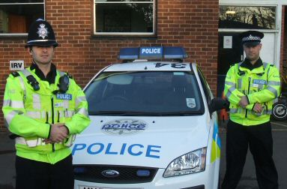

Call 999 without delay!

Would you be able to quickly and calmly give the address and postcode of the centre you’re working at?
Check it now and make a note of it on the next page.

Important Information

Use this space to record important information about your working environment.

My Programme Area Manager/Leader(s)

Name | Telephone | Email

Safeguarding Designated Persons at MACLS

Name | Telephone | Email

The address of the centre(s) I work in
Note the full address and postcode of the centre(s) you work in – you would need to give this to the emergency services quickly and calmly.

Centre | Full Address (inc Postcode)

Answers

Page 13 – The top causes of accidents in the workplace are slips, trips and falls, closely followed by manual handling accidents.

