**Intermediate cooking.**

**Week 1 Healthy Banana and Blueberry muffins**

**Nutritional Information (amount per serving)**

|  |  |  |  |  |  |  |
| --- | --- | --- | --- | --- | --- | --- |
| **Calories**  202kcals | **Carbs**  36g | **Sugar**  14g | **Fat**  5g | **Saturates**  0.8g | **Protein**  5g | **Salt**  0.59g |

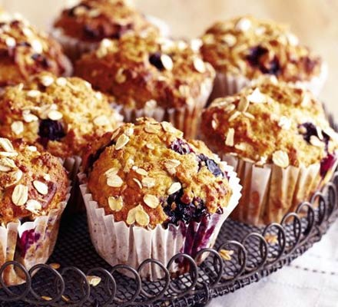

|  |  |  |
| --- | --- | --- |
| **Ingredients:**  300g self-raising flour  1 tsp bicarbonate of soda  100g light muscovado sugar  50g porridge oats, plus 1 tbsp for topping  2 medium bananas, the riper the better  284ml carton buttermilk  5 tbsp light olive oil  2 egg whites  150g punnet blueberries  **Method:** |  |  |

1. Heat oven to 180C/fan 160C/gas 4 and line a 12-hole muffin tin with paper muffin cases.
2. Tip the flour and bicarbonate of soda into a large bowl. Hold back 1 tbsp of the sugar, then mix the remainder with the flour and 50g oats.
3. Make a well in the centre. In a separate bowl, mash the bananas until nearly smooth. Stir the buttermilk, oil and egg whites into the mashed banana until evenly combined.
4. Pour the liquid mixture into the well and stir quickly and sparingly with a wooden spoon. The mix will look lumpy and may have the odd fleck of flour still visible, but don’t be tempted to over-mix. Tip in the blueberries and give it just one more stir. Divide the mix between the muffin cases – they will be quite full – then sprinkle the tops with the final tbsp of the oats and the rest of he sugar. Bake for 18-20 mins until risen and dark golden. Cool for 5 mins in the tray before lifting out onto a rack to cool completely.

*Recipe from Good Food magazine,* [*February 2006*](http://www.bbcgoodfood.com/search/recipes/date/1138752000)