RARPA PROCESS

Recognising and Recording

Progress & Achievement

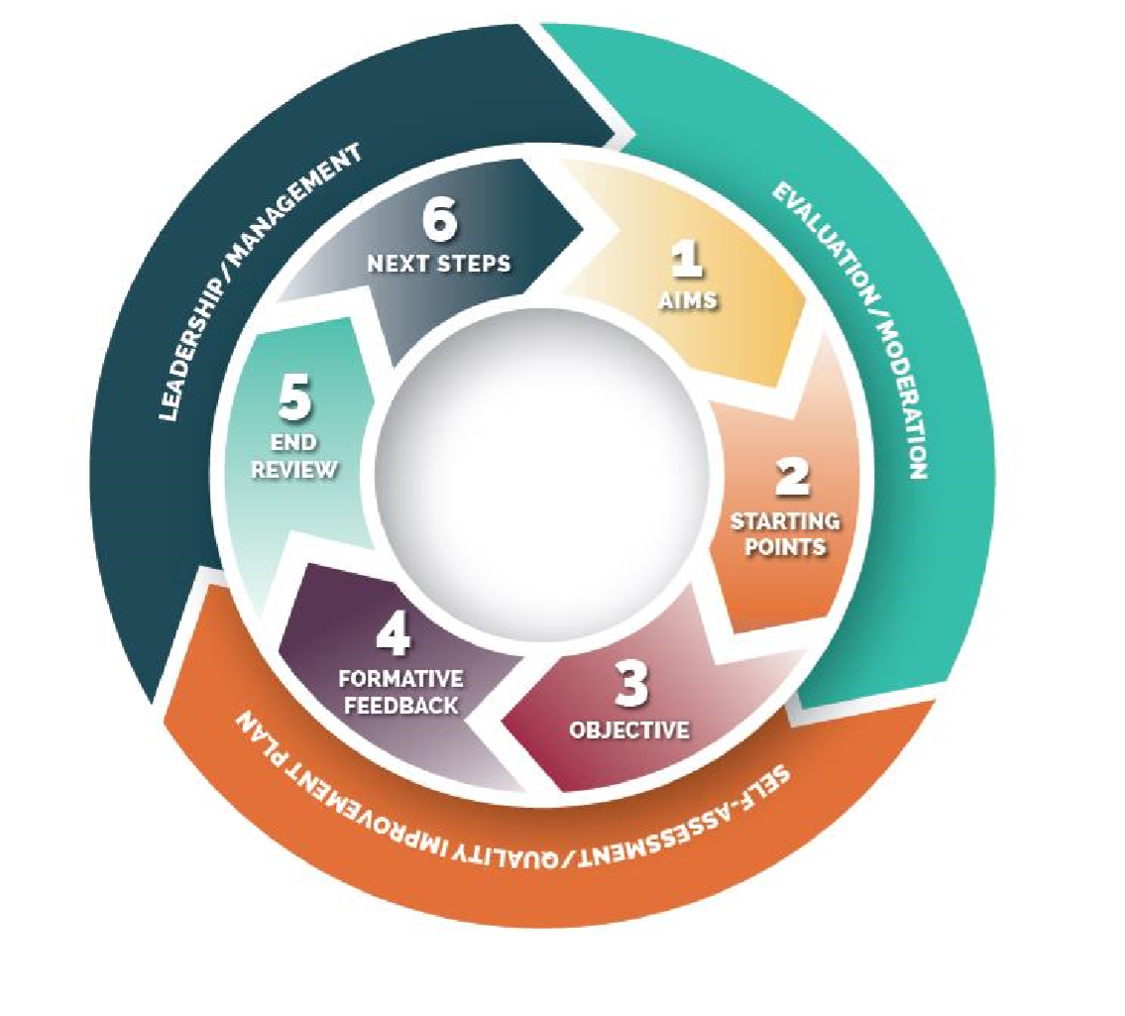

**Contents**

WHAT is RARPA?.....................................................................................3

There are two elements to the RARPA approach: ....................................3

The Staged Process ..................................................................................4

Success measures……………………………… .........................................5

RARPA and the quality improvement process............................................6

RARPA moderation process………………..................................................7

Appendix A . RARPA – Moderation Report................................................9

Appendix B. RARPA - 6 stage process for tutors.....................................11

**Recognising and Recording Progress and Achievement**

**What is RARPA?**

RARPA stands for Recognising and Recording Progress and Achievement in non-regulated learning. It’s a means of validating the outcomes of programmes which do not result in qualifications or other outcomes certified by awarding bodies.

**There are two elements to the RARPA approach:**

* The **Staged Process** consisting of five core steps which provide a means of recording progress and achievement for non-regulated learning
* **Quality assurance processes** for RARPA using providers’ existing self-assessment and continuous quality improvement processes

The **RARPA Staged Process** was revised in 2017 and consists of the following:

1. Setting a learning aim

2. Initial assessment

3. Identifying and negotiating learning objectives

4. Formative assessment

5. Summative assessment

6. Next steps and progression

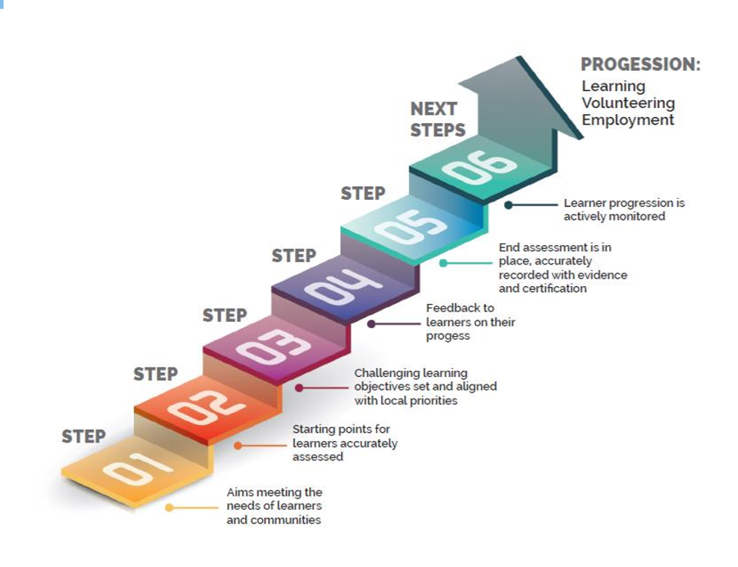

**The Staged Process**

1. **Aims**

* Explore aims in relation to the course and individuals
* Let learners have a hand in shaping the aims-ownership of aims will tend to increase focus and involvement
* Encourage people to think about experience, knowledge or skills they may already have.

1. **Initial Assessment**

* Talk to people about previous experience/knowledge/skills
* Build on previous successes and reduce the fear factor
* Develop activities that encourage people to share experiences/knowledge/skills
* Give people a practical task early on to provide feedback on skill levels
* Encourage people to reflect and self-assess from the outset
* Ask people to self-assess themselves against a given criteria

1. **Challenging Learning Objectives/Outcomes**

* The tutor and the learner/group need to agree challenging and stretching group and individual learning outcomes/targets according to learners’ needs, aspirations and starting points.
* SMART Outcomes/targets are set which support personal, community, social and economic goals of learners.
* The targets should be revised over time, depending on progress achieved

**SMART Outcomes/Targets**

**Specific –** Clear concise and focused- you state exactly what the learner will learn

**Measurable –** “How will we know if the outcome/target has been achieved?” If the answer is, “we don’t know!”, then the outcome/target isn’t measurable. It should be stated in terms of quality – exactly how will you and the learner know when they have achieved it?

**Achievable –** The learner must be able to reach the outcome/target; it must be at the right level. If the outcome/target is unachievable it will de-motivate the learner

**Realistic/relevant –** The outcome/target must be challenging, but be achievable – long and short term goals

**Time-bound –** Have an end date/ and or time frame in which actions take place. All those involved should be aware of the time set and the review date.

1. **Formative Assessment**

* Record what learners are achieving from the outset
* Encourage learners to self-assess
* Measure the learning in a session or series of sessions as appropriate
* Provide learners with clear feedback including detailed written feedback where appropriate so that learners can improve their performance
* Review individual and group progress and achievement
* Review the programme itself

1. **Summative Assessment**

* End of programme assessment. Use all appropriate assessment tools to measure ‘distance travelled’ and ‘value added’ end of programme including: records of learner self-assessment, group and peer assessment, tutor records of assessment activities and individual/group progress and achievement, learners’ files, portfolios, artwork, videos, audiotapes, performances, exhibitions and displays, individual or group learner testimony, artefacts, photographs and other forms of evidence
* Check whether the course met learners’ initial expectations
* Compare learners’ perceptions of knowledge/skill levels at the beginning of the course with those at the end
* Identify other gains including soft outcomes/ s e.g. confidence, social skills, increased employability maths and English.

1. **Next Steps**

* Support learners to make informed choices about their next steps.
* Identify future plans and progression
* Record on ILP and comple destination information.
* Refer to IAG Co-or or National career Service as appropriate.

**Success measures**

For non-regulated learning Medway Adult Eduction has set the following criteria for its success measure (based on an individual learner) for courses over 10 hours:

* Both individual and group learning outcomes must have been set
* Any ‘achieved’ outcomes must be fully met.
* At least half of the individual learner outcomes must be met.
* Achievements is to be calculated at 80% of learning outcomes

**Examples**

1. The following learning outcomes have been set:

5 Group learning outcomes 80% of 7 outcomes = 5.6

2 Individual learning outcomes outcomes.(Rounded up to 6)

There for the learner needs to

achieve 6 learning outcomes in total,

at which at least one must be an

individual outcome.

1. The following learning outcomes have been set:

4 Group learning outcomes 80% of 7 outcomes = 5.6

3 Individual learning outcomes outcomes.(Rounded up to 6)

Therefore, the learner needs

to achieve 6 learning outcomes

in total, of which at least 2 must

come from the individual outcomes.

**For courses less than 10 hours**

For programmes less than10 hours, where group objectives have been set, achievement is calculated at 80% of all learning outcomes.

**RARPA and the quality improvement process**

The RARPA cycle is underpinned by support factors and quality improvement and assurances processes. These processes are common to both non-regualted and regulated provision.

**Essential support factors**

The following elements are essential in underpinning the RARPA process:

* **Information, advice and guidance**. IAG is essential at all stages of the process to support learenrs to make informed choices about their future progression.
* **Staff development and observation of teaching and learning**. For new tutors support and additional training may be needed in formative and summative assessment. Observations of teaching, learning and assessment (OTLA) will cover include non-regualted learning and identify areas for improvement and good practice observed. Outcomes from OTLA will inform workforce development plans and CPD opportunities for tutors.
* **Management Information**: Collation and analysis of achievements and outcomes is required which are as rigoourous as for regulated provision. To ensure achievements are accurately identified good evidence must be provided to support achievement claims.
* **Curriculum review and management**: non-regulated provision should be reviewed alongside regulated qualification bearing courses to ensure that both provide the best fit to address local prioritises and individual needs.

**Quality improvement and Assurance**

It is expected that non-regulated provision will be treated with the same rigour as accredited provision.

* **Moderation:** moderation includes reviews of the RARPA cycle including assessment, achieved learning outcomes, ensuring challenging outcomes/targets are set and achieved and appropriate evidence is available capturing achievement of outcomes.
* **Self-Assessment:** Includes overall analysis of non-regulated outcomes and achievements. Reports show strengths, weaknesses and actions to improve weaknesses.
* **Leadership and Management**: evidence as to how RARPA and non-regulated provision is meeting the wder aims of the organisation, learners and local area. Leaders and Managers use the RARPA procerss to evaluate and plan improvements to the provision.

**RARPA Moderation Process**

**Why do we need to carry out RARPA moderation?**

* Feeds into our quality assurance processes and inform our self- assessment
* Develop tutors’ skills regarding the RARPA process
* Share good practice.

The process will consist of both internal and external moderations.

**Principles of RARPA internal moderation**

All non-accredited Medway Adult Eduction (MAE) programmes should be subject to internal moderation as part of our Quality Assurance Process for Teaching and Learning. The internal moderation process consists of regular internal moderation meetings to support improvement and identify and share good practice across the service.

It is the responsibility of each Programme Manager to ensure that they have taken part in this process.

**To work effectively, all staff involved in the internal moderation process must:**

* Be clear about the arrangements for moderation, quality improvements and performance management process and their role in the process and how it links to MAE’s Quality Assurance Process.

**Internal moderation activities include:**

* Sampling assessments from across all programme areas.
* Sampling whole learner files and checking RARPA and the Learners Journey has been recorded correctly

**The purpose of the moderation activity is to ensure:**

* The RARPA process is being followed consistently
* There is a standard approach to planning courses and recording progression and achievement in non-accredited learning
* Learner achievement is recorded appropriately as confirmed by the evidence in their files/other evidence
* There is consistency in the quality of assessment
* Feedback to learners is clear and appropriate
* Record-keeping mechanisms are maintained
* Good practice is recognised and shared

**The sample of learner work to be internally moderated should:**

* Be adequate in size to ensure that a judgement can be made in terms of consistency
* Include a random element to maintain rigour
* Cover the full range of attainment
* Identify problems or borderline learners
* Be representative of the whole programme in terms of all tutors and all courses.

**RARPA External Moderation**

**Purpose**

* To evaluate RARPA systems used by both contracted providers and MAE internal Moderation panel
* To identify and share good practice

**Process**

* If relevant - All contract providers will be subject to moderation, either by visit or by reviewing requested files
* The Head of Quality and Curriculum, Programem Managers, Programme Co-ordinators will particiate in a Regional external RARPA moderation event once a year with other SEQUIN members.

**Annual Actions**

* Arrange for files to be reviewed
* Write report on RARPA Moderation Process with actions for improvement by July each year
* Review process

**Appendix A**

**RARPA – Moderation Report**

|  |  |  |  |  |  |  |  |
| --- | --- | --- | --- | --- | --- | --- | --- |
| **Course Title:** | | | |  | | | **Tutor:** |
| **Course Code:** | | | **Start Date:** | **Y**  **✓** | **some extent** | **N**  **✓** | **Evidence/Comments/Recommendations:** |
| 1 | Aims | How relevant are the learning aims to the course content and level? | |  |  |  |  |
| 2 | Initial Assessment | How effective is Initial Assessment? | |  |  |  |  |
| How well is it linked to the course level and learners’ goals? (e.g. employability) | |
| Has the starting point been established? | |
| 3 | Appropriate and challenging learning outcomes/Objectives | Are course and individual learning outcomes appropriate to:   * the learner? * the level of the course? * the overall aim? | |  |  |  |  |
| Are they SMART? (Specific, Measurable, Achievable, Relevant and Timely) | |
| 4 | Recognition and Recording of Progress and Achievement/ Formative Assessment | Is the ILP an active document? | |  |  |  |  |
| Is there constructive feedback? | |
| Does feedback inform learners how to improve? | |
| Are learner objectives revisited and reviewed? | |
| 5 | Review of overall progress and achievement/ Summative Assessment | Is the achievement grade robust? | |  |  |  |  |
| Is it moderated/benchmarked? | |
| Is it valid? (completed and signed by tutor) | |
| **Moderator(s) names: Signatures: Date:** | | | | | | | |
| **Comments:** | | | | | | | |

**Appendix B RARPA – 6 Stage Process for Tutors**

**Stage 1 – Aims are appropriate to an individual or group of learenrs and local needs.**

* Clear statement of course outcomes
* Agreeing and stating learning aims and objectives of coursewhich meet the needs of learners.

**Stage 2 – Initial assessment (IA) to establish learners’ starting points**

* Identify your assessment tool/s for your course (questionnaire, checklist, practical activity, audition, writing, discussion, observation)
* Use your assessment tool/s to find the learners starting point
* Evidence the results of the assessment (observation record, discussion record, practical skills checklist, summary of skills)
* Keep the evidence in your course file and ILP
* Show evidence of changes to the scheme of work.

**Stage 3 – Identification of appropriate challenging learning outcomes**

* Use the initial assessments to plan the programme and learning activities.
* Identify the specific learning outcomes for your course.
* Clearly state them on the ILP .
* Explain the learning outcomes to the learners, clarifying their understanding.
* Explain formative assessment processes and feedback to the learners.
* Assess Learners against the learning outcomes.
* Set SMART targets – group and individual

**Stage 4 – Formative feedback and recognition and recording of progress and achievement during the programme**

* Record the progress of your learners – i.e. on-going reviews and mid-course reviews.
* Show evidence of changes made to scheme of work/lesson plans.
* Make time to provide written feedback which is detailed and informative.
* Evidence to be held in your course file and ILP

**Stage 5 – End of programme learner self-assessment and tutor summative assessment**

* Learners confirm their achievements through self-assessment, on their ILP and include additional comments about their progress.
* Tutors confirm learners’ progress and achievements.
* Evidence of achievements to be kept in the course file until the moderation cycle is completed (photographic images, video/CD, written documentation, completed log, audio recording; examples of learner’s work)

**Stage 6 – Next Steps**

* Discuss progression and record learners next steps within the IAG section of the ILP.
* Complete destination section of ILP.
* Complete learner evaluations.
* Refer the learner for furthere advice to the MAE IAG Co-or or National Career Service if appropriate.